

WingS

Report #2 – Software Requirement Specification

|  |  |  |
| --- | --- | --- |
| **WingS** | | |
| **Group Members** | Đào Trọng Nghĩa | SE03220 |
| Lê Hồng Nhiên | SE03377 |
| Tạ Ngọc Duy | SE03267 |
| Đỗ Văn Tuấn | SE03297 |
| Hoàng Anh Tuấn | SE03108 |
| **Supervisor** | Mr. Nguyễn Văn Sang | |
| **Event code** | WS | |

**- Hanoi, 11/2016 -**

# SIGNATURE PAGE

AUTHOR: Tạ Ngọc Duy 05/11/2016

Team member

REVIEWERS: Đào Trọng Nghĩa /11/2016

Event Manager

APPROVAL: Nguyễn Văn Sang --/--/--16

Supervisor

Record of change

*A - Added M - Modified D – Deleted

|  |  |  |  |  |  |
| --- | --- | --- | --- | --- | --- |
| Effective Date | Changed Item | A,M,D | Change Description | Reason for Change | Rev. Number |
| 05/11/2016 | Create Software Requirements Specifications | A | First version | Create Software Requirements Specifications | 1.0 |
|  |  |  |  |  |  |
|  |  |  |  |  |  |
|  |  |  |  |  |  |
|  |  |  |  |  |  |
|  |  |  |  |  |  |
|  |  |  |  |  |  |
|  |  |  |  |  |  |
|  |  |  |  |  |  |
|  |  |  |  |  |  |
|  |  |  |  |  |  |
|  |  |  |  |  |  |
|  |  |  |  |  |  |
|  |  |  |  |  |  |
|  |  |  |  |  |  |
|  |  |  |  |  |  |
|  |  |  |  |  |  |

Table Contents

SIGNATURE PAGE 2

**1.** **INTRODUCTION** 4

**1.1.** **Purpose** 4

**1.2.** **Definitions and Acronyms** 4

**1.3.** **System Purpose** 5

**2.** **OVERALL DESCRIPTION** 5

**2.1.** **System overview** 5

**2.2.** **Use Case Diagram** 7

**2.3.** **Product Features** 7

**2.3.1.** **User Characteristics** 9

**2.3.2.** **User Documentation** 10

**2.3.3.** **Assumption** 10

**2.4.** **Entity Relation Model** 10

**2.4.1.** **Entity-Relationship Diagram** 10

**2.4.2.** **Entity Detail** 11

**3.** **FUNCTIONAL SPECIFICATION** 14

**3.1.** **Business Rules** 14

**3.2.** **Use Cases** 16

**3.2.1.** **Guest/ Registered Group Function** 16

**3.2.2.** **Guest Group Function** 36

**3.2.3.** **Registered Group Function** 38

**3.2.4.** **Administrator Group Function** 54

**4.** **NON-FUNCTIONAL SPECIFICATION** 96

**4.1.** **Reliability** 96

**4.2.** **Performance Requirements** 96

**4.2.1.** **Availability** 96

**4.2.2.** **Response time** 96

**4.2.3.** **Maintainability** 96

**4.2.4.** **Usability** 97

**4.2.5.** **Security Requirements** 97

**4.2.6.** **Hardware/Software Requirements** 97

# **INTRODUCTION**

## **Purpose**

This document is created as the introduction for event WingS– our Capstone Event at FPT University. In this document, we provide the describing of general requirement and non-functional requirements. These requirements will assure that the system will correctly and reliably perform its intended functionality. This specification will provide general, as well as specific requirements to be used in the design, testing and validation of the system. It is intended for both stakeholders and the event team of the system.

## **Definitions and Acronyms**

|  |  |  |
| --- | --- | --- |
| **Acronym** | **Definition** | **Note** |
| WS | WingS System |  |
| SRS | Software Requirements Specifications |  |
| Guest | WS’s user who did not register |  |
| Registered | WS’s user who registered |  |
| Admin | WS’s administrator |  |
| User | WS’s user |  |

Table 2-1: Definition and Acronyms

## **System Purpose**

WS makes connections that enable people to help themselves and each other. Website allows users (person or organizations) create charity topics or raise fund event as long as it follows our rules to help other people. Backers can also take part in a event by donating money through a single donation or supporting event as a regular donor publicly or privately, not to profit financially. Instead, charity topic creators offer rewards to thank backers for their support. We hope our event can help as much people as we can in our country.

# **OVERALL DESCRIPTION**

## **System overview**

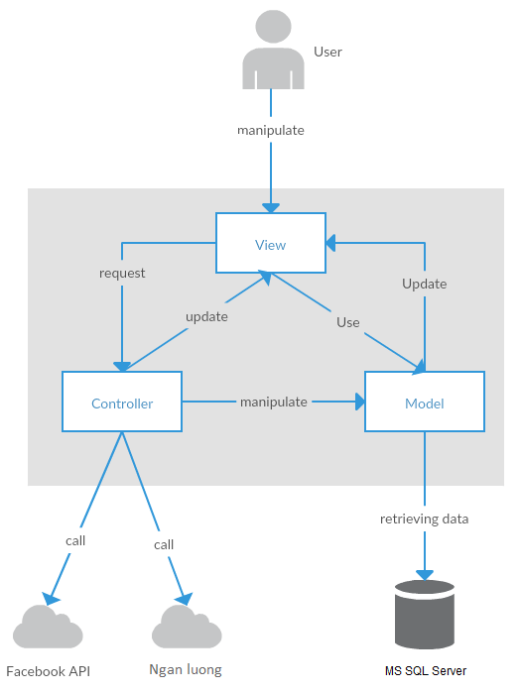

Figure 2-1: System Overview

## **Use Case Diagram**

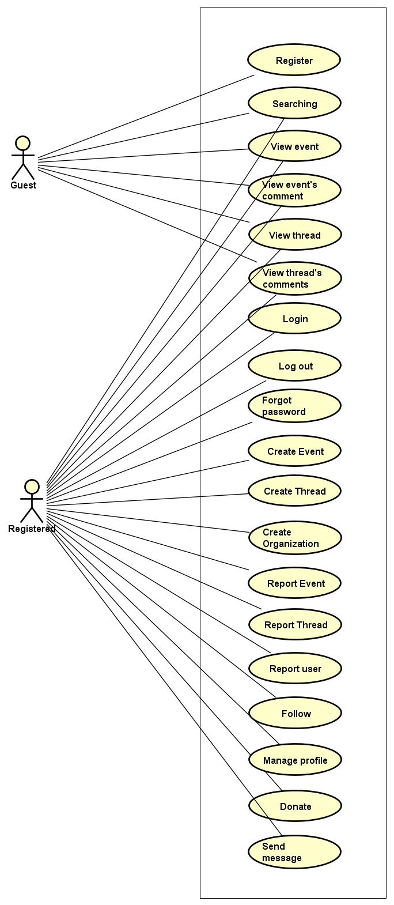

Figure 2-2: User use case diagram of WS system

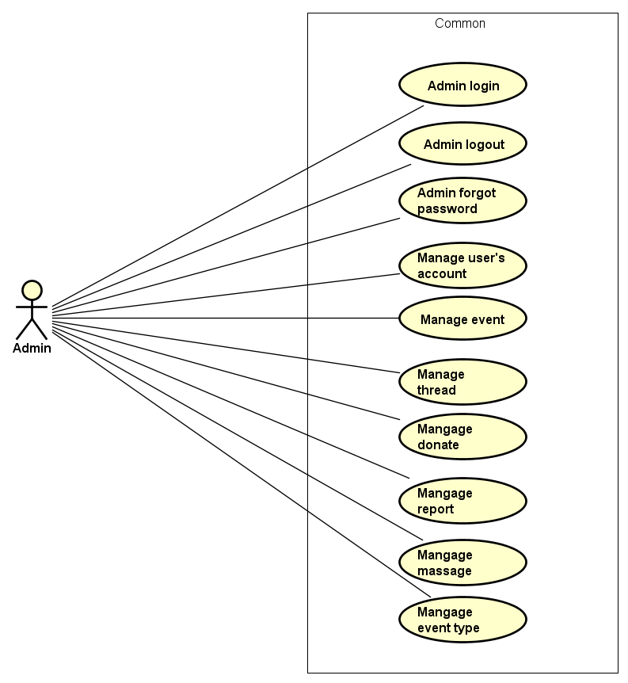

Figure 2-3: Admin use case diagram of WS system

## **Product Features**

|  |  |  |  |
| --- | --- | --- | --- |
| UC No. | Group Of Functions | Function | Glossary |
| Guest/Registered | | | |
|  | Common | Searching (User, Event, thread or organization) |  |
|  | View event | View event |  |
|  | View event’s comments |  |
|  | View thread |  |
|  | View thread’s comments |  |
| Guest | | | |
|  | Common | Register |  |
| Registered | | | |
|  | Common | Login |  |
|  | Logout |  |
|  | Forgot password |  |
|  | Create event |  |
|  | Create thread |  |
|  | Create Organization |  |
|  | Report Event |  |
|  | Report Thread |  |
|  | Report User |  |
|  | Follow Event |  |
|  |  | Donate |  |
|  | View Personal page | View other profile |  |
|  | View profile |  |
|  | View number created thread |  |
|  | View participated event |  |
|  | View point |  |
|  | Edit profile |  |
|  | Message | Send message |  |
|  | Group message |  |
|  | Receive message |  |
|  | Comment | View list comment |  |
|  | Post comment |  |
|  | Reply comment |  |
|  | Delete comment |  |
|  | Chat room | Go to room chat |  |
|  | View all other’s message |  |
|  | Receive message |  |
|  | Send message |  |
| Administrator | | | |
|  | Common | Admin login |  |
|  | Admin logout |  |
|  | Admin forgot password |  |
|  | Manage user's account | View list user |  |
|  | View user profile |  |
|  | Activate user's account |  |
|  | Deactivate user's account |  |
|  | View user’s dashboard |  |
|  | Manage event | View event’s dashboard |  |
|  | Active event |  |
|  | De-active event |  |
|  | View event detail |  |
|  | Search event |  |
|  | Manage donate | View list backing |  |
|  | Search backing |  |
|  | View backing's information |  |
|  | Export list backings |  |
|  | Manage Thread | View list thread |  |
|  | Activate thread |  |
|  | Deactivate thread |  |
|  | Search thread |  |
|  | View thread detail |  |
|  | Manage Messages | View list messages |  |
|  | Receive message |  |
|  | Send message |  |
|  | Delete message |  |
|  | Delete message |  |
|  | Manage Organization | View list Organization |  |
|  | Activate thread |  |
|  | Deactivate thread |  |
|  | Manage Reports | View list reports |  |
|  | View report detail |  |
|  | Change report's status |  |

Table 2-2: List of use case diagram

### **User Characteristics**

WS website towards to anyone wants to create an event on WingS as long as it follows our rules. Event creators set a donation goal and timeline. If have interested in event, they can donate this event by money or efforts. Donors are supporting event and help it to success and help as much people as they can, not to profit financially. Instead, WS system offer rewards to thank donors for their support by activities point. WS has three main objective users:

* **Guest:** Users did not register, they can use some function like Register, view event or thread, Search, etc...
* **Registered**: Users have account on WS, they can use almost functions of WS for user like Login, Logout, Create, Edit event, Comment, Report, etc…
* **Administrator:** They can use all functions of normal member and have an Administrator control panel to manage all information, event, user and configuration of WS.

### **User Documentation**

|  |  |
| --- | --- |
| Name | Description |
| User Guide | Provide detailed explanation about the system, screens and guide users how to use all features of WS. |

Table 2-3: User Documentation

### **Assumption**

* Receive the guidance and good support of teacher.
* No one of member got sick in the software development process.
* In the development process, no device got fail.
* Every report, task meets the deadline.
* Team member do not conflict in the work process.

## **Entity Relation Model**

### **Entity-Relationship Diagram**

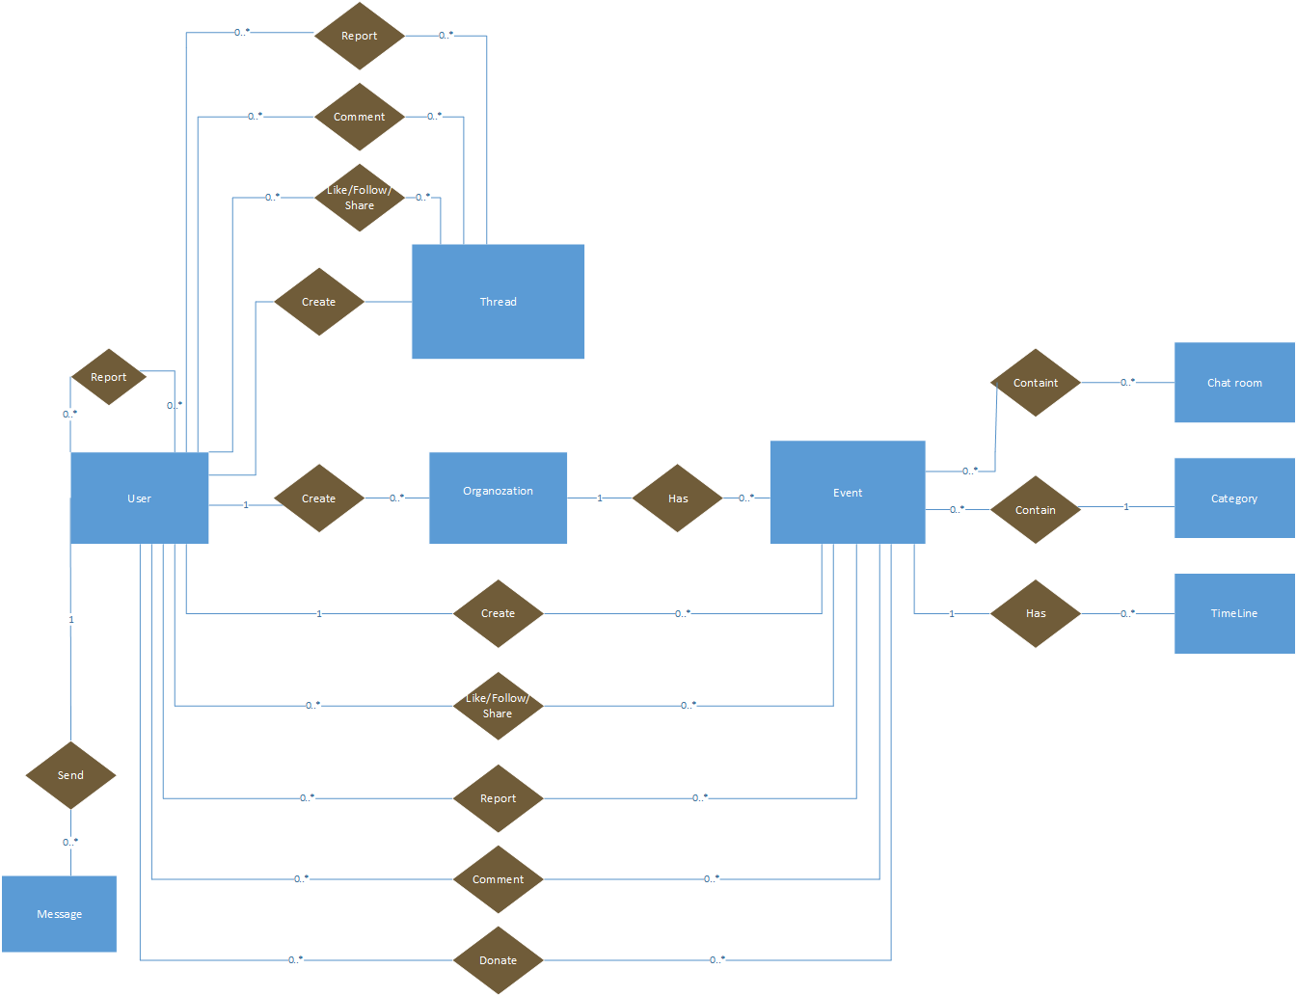

**Figure 2-3:** Entity Relationship Diagram

### **Entity Detail**

#### WS_User

|  |  |  |  |  |
| --- | --- | --- | --- | --- |
| No | Attribute | Type | Mandatory | Description |
|  | UserID | Int | Y | User’s ID |
|  | UserName | String | Y | User’s name |
|  | Password | String | Y | User’s password |
|  | AccountType | String | Y | User’s type (admin or normal user) |
|  | IsActive | Bit | Y | User’s active status (inactive, active) |
|  | IsVerify | Bit | Y | User’ email verify status |
|  | CreatedDate | Date | Y | User’s created date |
|  | LastLogin | Date | Y | User’s last login |
|  | Email | String |  | User’s email |
|  | VerifyCode | String |  | User’s verify code |

Table 2-4: WS-User

#### Organization

|  |  |  |  |  |
| --- | --- | --- | --- | --- |
| No | Attribute | Type | Mandatory | Description |
|  | OrganizationID | Int | Y | Organization’s |
|  | OrganizationName | String | Y | Organization’s Name |
|  | EOrganizationName | String |  | EOrganization’s Name |
|  | Introduction | String |  | Organization’s introduction |
|  | LogoUrl | String |  | Organization’s image link |
|  | Phone | String |  | Organization’s phone |
|  | Email | String |  | Organization’s email |
|  | Address | String |  | Organization’s address |
|  | Status | Bit | Y | Is Organization expired |
|  | Point | Int | Y |  |

Table 2-5: Organization

#### Thread

|  |  |  |  |  |
| --- | --- | --- | --- | --- |
| No | Attribute | Type | Mandatory | Description |
| 1 | ThreadIdID | Int | Y | Thread’s ID |
| 2 | UserId | Int | Y | UserID who created thread |
| 3 | Title | String | Y | Thread’s title |
| 4 | Etitle | String | Y | Thread’s ETitle |
| 5 | [Content] | String | Y | Thread’s content |
| 6 | VideoUrl | String | Y | Thread’s video link |
| 7 | CreatedDate | Date | Y | Thread’s created date |
| 8 | UpdatedDate | Date | Y | Thread’s updated date |
| 9 | Status | Bit | Y | Thread’s status: active or banned |

Table 2-5: Thread

#### Event

|  |  |  |  |  |
| --- | --- | --- | --- | --- |
| No | Attribute | Type | Mandatory | Description |
| 1 | EventID | Int | Y | Event’s ID |
| 2 | CreatorID | Int | Y | UserID who created event |
| 3 | EventType | String | Y | Event’s type |
| 4 | EventName | String | Y | Event’s name |
| 5 | EEventName | String | Y | EEvent’s name |
| 6 | Created_Date | Date | Y | Event’s created date |
| 7 | Start_Date | Date | Y | Event’s start date |
| 8 | Finish_Date | Date | Y | Event’s finish date |
| 9 | UpdatedDate | Date | Y | Event’s updated date |
| 10 | Contact | String | Y | Contact of event’s creator |
| 11 | ShortDescription | String | Y | Event’s short description |
| 12 | Description | String | Y | Event’s description |
| 13 | Location | String | Y | Event’s location |
| 14 | VideoUrl | String | Y | Event’s video link |
| 15 | ExpectedMoney | Float | Y | Amount Money which event expected |
| 16 | TotalPoint | Int | Y | Total point of event |
| 17 | Status | Bit | Y | Event’s status |

Table 2-5: Event

#### Event Type

|  |  |  |  |  |
| --- | --- | --- | --- | --- |
| No | Attribute | Type | Mandatory | Description |
| 1. 1 | EventTypeID | Int | Y | Event type’s ID |
| 1. 2 | EventName | String | Y | Event type’s name |
|  | [Content] | String | Y | Event type’s description |

Table 2-6: Event type

#### Event Timeline

|  |  |  |  |  |
| --- | --- | --- | --- | --- |
| No | Attribute | Type | Mandatory | Description |
| 1. 1 | TimelineID | Int | Y | Timeline’s ID |
| 1. 2 | EventId | Int | Y | Event’s id |
| 1. 3 | [Content] | String | Y | Timeline’s contents |
|  | FromDate | Date | Y | Timeline’s start date |
|  | ToDate | Date | Y | Timeline’s end date |
|  | Status | Bit | Y | Timeline’s status |

Table 2-8: Event Timeline

#### Event chat room

|  |  |  |  |  |
| --- | --- | --- | --- | --- |
| No | Attribute | Type | Mandatory | Description |
|  | PublicRoomId | Int | Y | Conversation’s ID |
|  | ConnectionId | Int | Y | Conversation’s creator id |
|  | EventId | Int | Y | Conversation’s receiver |

Table 2-13: Event chat room

#### Message table

|  |  |  |  |  |
| --- | --- | --- | --- | --- |
| No | Attribute | Type | Mandatory | Description |
| 1. 1 | MessageID | Int | Y | Message’s ID |
| 1. 2 | ConversationID | Int | Y | Message’s conversation id |
| 1. 3 | UserID | Int | Y | Message’s user id |
|  | CreatedDate | Date | Y | Message’s sent time |
|  | Content | String | Y | Message’s content |
|  | Status | Bit | Y | Message’s status |

Table 2-11: Message table

# **FUNCTIONAL SPECIFICATION**

## **Business Rules**

|  |  |
| --- | --- |
| **No** | **Description** |
|  | Search textbox cannot be empty |
|  | Content is unlimited characters |
|  | Chat box cannot be empty |
|  | Subject is limited to 1000 characters |
|  | Name cannot be empty |
|  | If user accesses to nonexistent page, WS displays error message “Error” |
|  | Email must content characters ‘@’ and ‘.’ |
|  | Date of birth must be chosen |
|  | Displayed date is mm/dd/yyyy format |
|  | Date time input format is datetime |
|  | Number is rounded to 2 decimal number |
|  | Unit of money is VND |
|  | Displayed money is rounded to 2 decimal number |
|  | Allowed file extension: .jpg, .png, .bmp |
|  | File size is limited to 100 MB |
|  | Message displayed like a Gmail format |
|  | Rank is calculated depending on point which gain from donating event or creating thread |

Table 2-13: Business rules

## **Use Cases**

### **Guest/ Registered Group Function**

#### Common Module

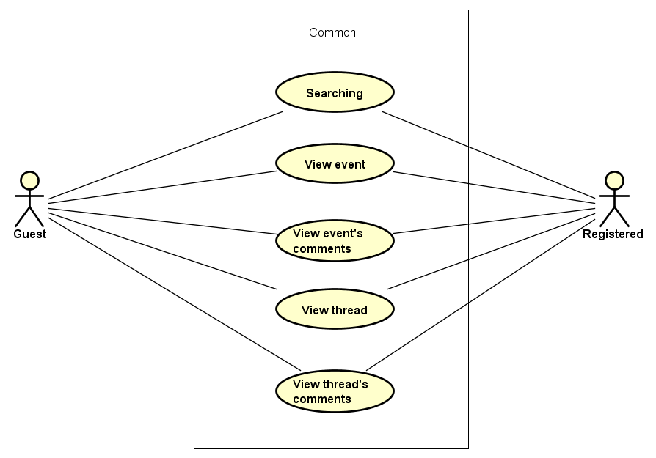

Figure 3-1: Common module use case

##### UC001-Searching

|  |  |  |  |  |
| --- | --- | --- | --- | --- |
| **Use Case ID** | | UC001 | **Version** | 1.0 |
| **Use Case Name** | | Search event | | |
| **Created by:** | | DuyTN | **Date Created:** | 05/11/2016 |
| **Primary Actor** | | Registered user  Guest | **Secondary Actor** |  |
| **Priority** | | High | | |
| **Frequency of Use:** | | High | | |
| **Description:** | | This function allows user to search existing information about Search existing information about User, Account, Event, Thread or  Organization | | |
| **Preconditions:** | | 1. WS website is available 2. User browsed WS website | | |
| **Trigger:** | | User enters search phrase, choose the search type (User, Account, Event, Thread or  Organization) and click Search or press Enter | | |
| **Post conditions:** | | List all results that matched with the keyword user enters will be displayed bellow Search screen | | |
| **Normal Flow** | | | | |
| **Step** | **Actor** | **Action** | | |
| 1 | User | Enter search phrase to text box | | |
| 2 | User | Choose one of bellow search type (User, Account, Event, Thread or  Organization) | | |
| 3 | User | Click Search icon or press Enter | | |
| 4 | WS | List all results that matched with the keyword user entered in. | | |
| **Alternative Flows:** | | | | |
| **Exceptions: N/A** | | | | |
| **Business Rules:** | | B1 | | |
| **Other Information:** | | N/A | | |

Table 2- 15: Searching Use case

##### UC002-View event

|  |  |  |  |  |
| --- | --- | --- | --- | --- |
| **Use Case ID** | | UC002 | **Version** | 1.0 |
| **Use Case Name** | | View event | | |
| **Created by:** | | DuyTN | **Date Created:** | 05/11/2016 |
| **Primary Actor** | | Registered user  Guest | **Secondary Actor** |  |
| **Priority** | | High | | |
| **Frequency of Use:** | | High | | |
| **Description:** | | This function allows user to show all existing events and event detail stored on WS | | |
| **Preconditions:** | | 1. WS website is available 2. User browsed WS website | | |
| **Trigger:** | | User click “Event” | | |
| **Post conditions:** | | Event information will be displayed in the Event detail screen | | |
| **Normal Flow** | | | | |
| **Step** | **Actor** | **Action** | | |
| 1 | User | Click Event | | |
| 2 | WS | List all existing event | | |
| 3 | User | Click on one event | | |
| 4 | WS | Redirect to event detail page | | |
| **Alternative Flows:** | | | | |
| **AT1** | At step 3 in the main flows, if user click other hyperlinks or buttons | | | |
| **Step** | **Actor** | **Action** | | |
| 1.0 | WS | Redirects user to chosen hyperlink or button | | |
|  | | | | |
| **Exceptions: N/A** | | | | |
| **Business Rules:** | | N/A | | |
| **Other Information:** | | N/A | | |

Table 2- 14: View event Use case

##### UC003-View event’s comment

|  |  |  |  |  |
| --- | --- | --- | --- | --- |
| **Use Case ID** | | UC003 | **Version** | 1.0 |
| **Use Case Name** | | View event’s comment | | |
| **Created by:** | | DuyTN | **Date Created:** | 05/11/2016 |
| **Primary Actor** | | Registered user  Guest | **Secondary Actor** |  |
| **Priority** | | High | | |
| **Frequency of Use:** | | High | | |
| **Description:** | | This function allows user to show all comment stored in a event | | |
| **Preconditions:** | | 1. WS website is available 2. User browsed WS website | | |
| **Trigger:** | | User click “Event” | | |
| **Post conditions:** | | List all Event’s comment will be displayed in the Event detail screen | | |
| **Normal Flow** | | | | |
| **Step** | **Actor** | **Action** | | |
| 1 | User | Click Event | | |
| 2 | WS | List all existing event | | |
| 3 | User | Click on 1 event and scroll down | | |
| 4 | WS | Display all comment in event | | |
| **Alternative Flows:** | | | | |
| **AT1** | At step 1 in the main flows, if user click other hyperlinks or buttons | | | |
| **Step** | **Actor** | **Action** | | |
| 1.0 | WS | Redirects user to chosen hyperlink or button | | |
|  | | | | |
| **Exceptions: N/A** | | | | |
| **Business Rules:** | | N/A | | |
| **Other Information:** | | N/A | | |

Table 2- 14: View comment in Event Use case

##### UC004-View thread

|  |  |  |  |  |
| --- | --- | --- | --- | --- |
| **Use Case ID** | | UC004 | **Version** | 1.0 |
| **Use Case Name** | | View thread | | |
| **Created by:** | | DuyTN | **Date Created:** | 05/11/2016 |
| **Primary Actor** | | Registered user  Guest | **Secondary Actor** |  |
| **Priority** | | High | | |
| **Frequency of Use:** | | High | | |
| **Description:** | | This function allows user to show all existing event stored on WS | | |
| **Preconditions:** | | 1. WS website is available 2. User browser WS is available | | |
| **Trigger:** | | User click “Thread” | | |
| **Post conditions:** | | Thread information will be displayed in the Thread detail screen | | |
| **Normal Flow** | | | | |
| **Step** | **Actor** | **Action** | | |
| 1 | User | Click Thread | | |
| 2 | WS | List all existing Thread | | |
| 3 | User | Click on one thread in the list | | |
| 4 | WS | Redirect and Display information of thread in thread detail page | | |
| **Alternative Flows:** | | | | |
| **AT1** | At step 1 in the main flows, if user click other hyperlinks or buttons | | | |
| **Step** | **Actor** | **Action** | | |
| 1.0 | WS | Redirects user to chosen hyperlink or button | | |
| **Exceptions: N/A** | | | | |
| **Business Rules:** | | N/A | | |
| **Other Information:** | | N/A | | |

Table 2- 14: View thread Use case

##### UC005-View thread’s comment

|  |  |  |  |  |
| --- | --- | --- | --- | --- |
| **Use Case ID** | | UC005 | **Version** | 1.0 |
| **Use Case Name** | | View event’s comment | | |
| **Created by:** | | DuyTN | **Date Created:** | 05/11/2016 |
| **Primary Actor** | | Registered user  Guest | **Secondary Actor** |  |
| **Priority** | | High | | |
| **Frequency of Use:** | | High | | |
| **Description:** | | This function allows user to show all comment stored in event | | |
| **Preconditions:** | | 1. WS website is available 2. User browsed WS website | | |
| **Trigger:** | | User click “Thread” | | |
| **Post conditions:** | | List all Thread’s comment will be displayed in the Thread detail screen | | |
| **Normal Flow** | | | | |
| **Step** | **Actor** | **Action** | | |
| 1 | User | Click Thread | | |
| 2 | WS | List all existing thread | | |
| 3 | User | Click on 1 thread and scroll down | | |
| 4 | WS | Display all comment in thread | | |
| **Alternative Flows:** | | | | |
| **AT1** | At step 1 in the main flows, if user click other hyperlinks or buttons | | | |
| **Step** | **Actor** | **Action** | | |
| 1.0 | WS | Redirects user to chosen hyperlink or button | | |
|  | | | | |
| **Exceptions: N/A** | | | | |
| **Business Rules:** | | N/A | | |
| **Other Information:** | | N/A | | |

Table 2- 14: View comment in thread Use case

### **Guest Group Function**

#### Common Module

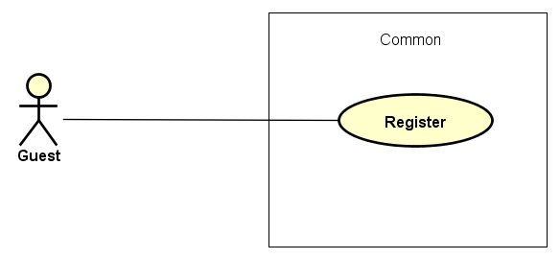

Figure 3-2: Guest common use case

##### UC006-Register

|  |  |  |  |  |  |
| --- | --- | --- | --- | --- | --- |
| **Use Case ID** | | | UC006 | **Version** | 1.0 |
| **Use Case Name** | | | Register | | |
| **Created by:** | | | DuyTN | **Date Created:** | 05/11/2016 |
| **Primary Actor** | | | Guest | **Secondary Actor** |  |
| **Priority** | | | High | | |
| **Frequency of Use:** | | | High | | |
| **Description:** | | | Visitor can create new account to use more function as a register user | | |
| **Preconditions:** | | | 1. WS must be connected to the Internet 2. User browsed WS website | | |
| **Trigger:** | | | Click on register link on the website | | |
| **Post conditions:** | | | 1. Add account information to database 2. Send confirm email 3. Save user information into system 4. Redirect user to confirm validate code page 5. Display login screen | | |
| **Normal Flow** | | | | | |
| **Step** | **Actor** | | **Action** | | |
|  | User | | Click Register in header | | |
|  | WS | | Display Register page includes:   * Header * User name text box * Password text box * Confirm password text box * Email text box * Register button * Cancel button | | |
|  | User | | Enters data in fields | | |
|  | User | | Click Register | | |
|  | WS | | Send confirm validate code email | | |
|  | WS | | Logs user into system | | |
|  | WS | | Display validate code page | | |
|  | WS | | Display login page | | |
| **Alternative Flows** | | | | | |
| **AT1** | At step 4, user click Cancel | | | | |
| **Step** | **Actor** | | **Action** | | |
| 4.1 | WS | | Redirects user to previous page | | |
|  | | | | | |
| **AT2** | At step 4 in the main flows, if user click other hyperlinks or buttons | | | | |
| **Step** | **Actor** | **Action** | | | |
| 4.1 | WS | Redirects user to chosen hyperlink or button | | | |
|  | | | | | |
| **Exceptions:** | | | | | |
| **EC1** | At step 4, required fields are not entered | | | | |
| **Step** | **Actor** | | **Action** | | |
| 4.1 | WS | | Display Register page with message: with ID MSG5 | | |
| 4.2 | WS | | Mark error fields | | |
|  | | | | | |
| **EC2** | At step 4, fields are entered with wrong type of data | | | | |
| **Step** | **Actor** | | **Action** | | |
| 4.1 | WS | | Display Register page with message: with ID MSG6 | | |
| 4.2 | WS | | Mark error fields | | |
| **Business Rules:** | | |  | | |
| **Other Information:** | | | N/A | | |

Table 2- 30: Register Use case

### **Registered Group Function**

#### Common module

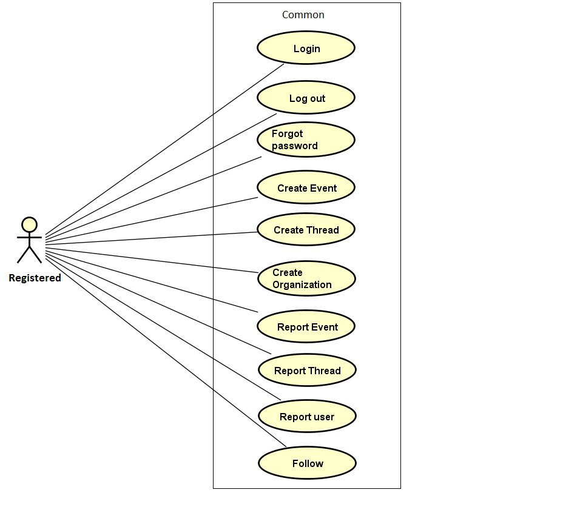

Figure 3-3: Registered common use case

##### UC007- Login

|  |  |  |  |  |
| --- | --- | --- | --- | --- |
| **Use Case ID** | | UC007 | **Version** | 1.0 |
| **Use Case Name** | | Login by social network’s account  Login by registered account | | |
| **Created by:** | | DuyTN | **Date Created:** | 05/11/2016 |
| **Primary Actor** | | Registered User | **Secondary Actor** |  |
| **Priority** | | High | | |
| **Frequency of Use:** | | High | | |
| **Description:** | | When User want to login by Facebook/Register account to use more functions in website | | |
| **Preconditions:** | | 1. WS must be connected to the Internet 2. User browsed WS website 3. Account Facebook/Register must be exist and correctly 4. User is viewing Login page | | |
| **Trigger:** | | User enter wings.com | | |
| **Post conditions:** | | 1. Log user into system 2. Redirect user to previous page and display as Member | | |
| **Normal Flow** | | | | |
| **Step** | **Actor** | **Action** | | |
|  | User | Click Login in Homepage | | |
|  | WS | Redirect to Login page includes:   * User name text box * Password text box * Login button * Cancel button * Facebook button * Forgot password hyperlink * Remember me check box | | |
|  | User | Enters User name and Password | | |
|  | User | Click Login | | |
|  | WS | Logs user into system | | |
|  | WS | Redirect to Homepage | | |
|  | WS | Display previous page as Member | | |
| **Alternative Flows** | | | | |
| **AT1** | At step 3 in the main flows, if user click Facebook button | | | |
| **Step** | **Actor** | **Action** | | |
| 3.1 | WS | Redirects user to confirm site | | |
| 3.2 | WS | Logs user into system with Facebook account | | |
|  | | | | |
| **AT2** | At step 4, user choose Cancel: | | | |
| **Step** | **Actor** | **Action** | | |
| 4.1 | WS | Closes popup. | | |
|  | | | | |
| **AT3** | At step 8 in the main flows, if user click other hyperlinks or buttons | | | |
| **Step** | **Actor** | **Action** | | |
| 8.1 | WS | Redirects user to chosen hyperlink or button | | |
|  | | | | |
| **Exceptions:** | | | | |
| **EC1** | At step 4 in main flow, if user entered wrong User name or Password | | | |
| **Step** | **Actor** | **Action** | | |
| 3.1 | WS | Display Login popup message with ID MSG14 | | |
| 3.2 | WS | Mark error fields | | |
| **Business Rules:** | | N/A | | |
| **Other Information:** | | N/A | | |

Table 2- 31: Login Use case

##### UC008- Logout

|  |  |  |  |  |
| --- | --- | --- | --- | --- |
| **Use Case ID** | | UC008 | **Version** | 1.0 |
| **Use Case Name** | | Logout | | |
| **Created by:** | | DuyTN | **Date Created:** | 05/11/2016 |
| **Primary Actor** | | User | **Secondary Actor** |  |
| **Priority** | | High | | |
| **Frequency of Use:** | | High | | |
| **Description:** | | When User want to logout their account | | |
| **Preconditions:** | | 1. WS must be connected to the Internet 2. User browsed WS website 3. User logged in to system | | |
| **Trigger:** | | User click Logout in user menu | | |
| **Post conditions:** | | 1. Log user out from system. 2. Redirect user to guest homepage view | | |
| **Normal Flow** | | | | |
| **Step** | **Actor** | **Action** | | |
| 1 | User | Click Logout | | |
| 2 | WS | Display page as Guest | | |
| **Alternative Flows: N/A** | | | | |
| **Exceptions: N/A** | | | | |
| **Business Rules:** | | N/A | | |
| **Other Information:** | | N/A | | |

Table 2- 32: Logout Use case

##### UC009- Forgot password

|  |  |  |  |  |
| --- | --- | --- | --- | --- |
| **Use Case ID** | | UC009 | **Version** | 1.0 |
| **Use Case Name** | | Forgot password | | |
| **Created by:** | | DuyTN | **Date Created:** | 05/11/2016 |
| **Primary Actor** | | User | **Secondary Actor** |  |
| **Priority** | | Normal | | |
| **Frequency of Use:** | | Normal | | |
| **Description:** | | When Member forgot their password to login the system, this function will receiving their password to email | | |
| **Preconditions:** | | 1. WS must be connected to the Internet 2. User browsed WS website 3. User logged in to system | | |
| **Trigger:** | | Click Forgot password in Login popup | | |
| **Post conditions:** | | 1. Send confirm email | | |
| **Normal Flow** | | | | |
| **Step** | **Actor** | **Action** | | |
|  | User | Click Forgot password in Login page | | |
|  | WS | Display Email text box | | |
|  | User | Enter registered email | | |
|  | User | Click Get password | | |
|  | WS | Sends confirm email | | |
|  | WS | Display message: | | |
| **Alternative Flows** | | | | |
| **AT2** | At step 3 in the main flow, user clicks on Cancel button | | | |
| **Step** | **Actor** | **Action** | | |
| 3.1 | WS | Return to previous screen | | |
|  | | | | |
| **AT2** | At step 4 in the main flows, if user click other hyperlinks or buttons | | | |
| **Step** | **Actor** | **Action** | | |
| 4.1 | WS | Redirects user to chosen hyperlink or button | | |
|  | | | | |
| **Exceptions:** | | | | |
| **EC1** | At step 4, entered email is invalid | | | |
| **Step** | **Actor** | **Action** | | |
| 4.1 | WS | Displays Login popup with message: with ID MSG15 | | |
| 4.2 | WS | Marks email text box | | |
| **Business Rules:** | | N/A | | |
| **Other Information:** | | N/A | | |

Table 2- 33: Forgot password Use case

##### UC010-Create Event

|  |  |  |  |  |
| --- | --- | --- | --- | --- |
| **Use Case ID** | | UC010 | **Version** | 1.0 |
| **Use Case Name** | | Create event | | |
| **Created by:** | | DuyTN | **Date Created:** | 05/11/2016 |
| **Primary Actor** | | Registered user | **Secondary Actor** |  |
| **Priority** | | High | | |
| **Frequency of Use:** | | High | | |
| **Description:** | | This function allows user to create an event | | |
| **Preconditions:** | | 1. WS website is available  2. User browsed WS website  3. User logged in to system  4. User has their own organization  5. User is on homepage or event page | | |
| **Trigger:** | | User click on button “Create Even” | | |
| **Post conditions:** | | Create an event page is displayed | | |
| **Normal Flow** | | | | |
| **Step** | **Actor** | **Action** | | |
| 1 | User | Click create event | | |
| 2 | WS | Show create event page | | |
| 3 | User | Fill all information about event | | |
| 4 | WS | Create button enable | | |
| 5 | User | Click on Create Event | | |
| 6 | WS | Event created and waiting for administrator accept. | | |
| **Alternative Flows: N/A** | | | | |
| **Exceptions:** | | | | |
| **EC1** | At step 3 in the main flows, if user don’t fill all information of event | | | |
| **Step** | **Actor** | **Action** | | |
| 3.1 | WS | Warning label display to remind user | | |
| **Business Rules:** | | N/A | | |
| **Other Information:** | | N/A | | |

Table 2- 34: Create event Use case

##### UC011- Create Thread

|  |  |  |  |  |
| --- | --- | --- | --- | --- |
| **Use Case ID** | | UC011 | **Version** | 1.0 |
| **Use Case Name** | | Share event | | |
| **Created by:** | | DuyTN | **Date Created:** | 05/11/2016 |
| **Primary Actor** | | Registered user | **Secondary Actor** |  |
| **Priority** | | High | | |
| **Frequency of Use:** | | High | | |
| **Description:** | | This function allows user to create a thread to discussion | | |
| **Preconditions:** | | 1.WS website is available  2.User browsed WS website  3.User logged in to system  4.User is on homepage or thread page | | |
| **Trigger:** | | User click on create thread button | | |
| **Post conditions:** | | Create an thread page is displayed | | |
| **Normal Flow** | | | | |
| **Step** | **Actor** | **Action** | | |
| 1 | User | Click create thread | | |
| 2 | WS | Show create thread page | | |
| 3 | User | Fill all information about thread | | |
| 4 | WS | Create button enable | | |
| 5 | User | Click on Create Thread | | |
| 6 | WS | Thread created has been created | | |
| **Alternative Flows: N/A** | | | | |
| **EC1** | At step 3 in the main flows, if user don’t fill all information of thread | | | |
| **Step** | **Actor** | **Action** | | |
| 3.1 | WS | Warning label display to remind user | | |
| **Exceptions: N/A** | | | | |
| **Business Rules:** | |  | | |
| **Other Information:** | | N/A | | |

Table 2- 35: Create Thread Use case

##### UC012- Create Organization

|  |  |  |  |  |
| --- | --- | --- | --- | --- |
| **Use Case ID** | | UC012 | **Version** | 1.0 |
| **Use Case Name** | | Star event | | |
| **Created by:** | | DuyTN | **Date Created:** | 05/11/2016 |
| **Primary Actor** | | Registered user | **Secondary Actor** |  |
| **Priority** | | High | | |
| **Frequency of Use:** | | High | | |
| **Description:** | | This function allows user to create an organization | | |
| **Preconditions:** | | 1.WS website is available  2.User browsed WS website  3.User logged in to system  4.User is on organization page | | |
| **Trigger:** | | User click on Create Organization button | | |
| **Post conditions:** | | Organization page is displayed | | |
| **Normal Flow** | | | | |
| **Step** | **Actor** | **Action** | | |
| 1 | User | Click create organization | | |
| 2 | WS | Show create thread page | | |
| 3 | User | Fill all information about thread | | |
| 4 | WS | Create button enable | | |
| 5 | User | Click on Create Thread | | |
| 6 | WS | Thread created has been created | | |
| **Alternative Flows: N/A** | | | | |
| **EC1** | At step 3 in the main flows, if user don’t fill all information of organization | | | |
| **Step** | **Actor** | **Action** | | |
| 3.1 | WS | Warning label display to remind user | | |
|  | | | | |
| **Exceptions: N/A** | | | | |
| **Business Rules:** | | N/A | | |
| **Other Information:** | | N/A | | |

Table 2- 36: Create Organization Use case

##### UC013- Report event

|  |  |  |  |  |
| --- | --- | --- | --- | --- |
| **Use Case ID** | | UC013 | **Version** | 1.0 |
| **Use Case Name** | | Report event | | |
| **Created by:** | | DuyTN | **Date Created:** | 05/11/2016 |
| **Primary Actor** | | Registered user | **Secondary Actor** |  |
| **Priority** | | Normal | | |
| **Frequency of Use:** | | High | | |
| **Description:** | | This function allows user to report an event | | |
| **Preconditions:** | | 1.WS website is available  2.User browsed WS website  3.User logged in to system  4.User is on event detail page | | |
| **Trigger:** | | User click on button report | | |
| **Post conditions:** | | Event detail page is displayed | | |
| **Normal Flow** | | | | |
| **Step** | **Actor** | **Action** | | |
| 1 | WS | Display all information of event | | |
| 2 | User | Click Report Button | | |
| 3 | WS | Show confirm dialog with question ask about reason | | |
| 4 | User | Fill reason then click send report | | |
| 5 | WS | Send report | | |
| **Alternative Flows: N/A** | | | | |
| **Exceptions: N/A** | | | | |
| **Business Rules:** | |  | | |
| **Other Information:** | | N/A | | |

Table 2- 37: Report Event Use case

##### UC014- Report thread

|  |  |  |  |  |
| --- | --- | --- | --- | --- |
| **Use Case ID** | | UC014 | **Version** | 1.0 |
| **Use Case Name** | | Report thread | | |
| **Created by:** | | DuyTN | **Date Created:** | 05/11/2016 |
| **Primary Actor** | | Registered user | **Secondary Actor** |  |
| **Priority** | | High | | |
| **Frequency of Use:** | | High | | |
| **Description:** | | This function allows user to report a thread | | |
| **Preconditions:** | | 1.WS website is available  2.User browsed WS website  3.User logged in to system  4.User is on thread detail page | | |
| **Trigger:** | | User click on button report | | |
| **Post conditions:** | | Thread detail page is displayed | | |
| **Normal Flow** | | | | |
| **Step** | **Actor** | **Action** | | |
| 1 | WS | Display all information of event | | |
| 2 | User | Click Report | | |
| 3 | WS | Show confirm dialog with question ask about reason | | |
| 4 | User | Fill reason then confirm | | |
| 5 | WS | Send report | | |
| **Alternative Flows: N/A** | | | | |
| **Exceptions: N/A** | | | | |
| **Business Rules:** | | N/A | | |
| **Other Information:** | | N/A | | |

Table 2- 37: Report thread Use case

##### UC015- Report user

|  |  |  |  |  |
| --- | --- | --- | --- | --- |
| **Use Case ID** | | UC015 | **Version** | 1.0 |
| **Use Case Name** | | Report user | | |
| **Created by:** | | DuyTN | **Date Created:** | 05/11/2016 |
| **Primary Actor** | | Registered user | **Secondary Actor** |  |
| **Priority** | | Normal | | |
| **Frequency of Use:** | | High | | |
| **Description:** | | This function allows user to report an user | | |
| **Preconditions:** | | 1.WS website is available  2.User browsed WS website  3.User logged in to system  4.User is on User profife page | | |
| **Trigger:** | | User click on button report | | |
| **Post conditions:** | | User profile page is displayed | | |
| **Normal Flow** | | | | |
| **Step** | **Actor** | **Action** | | |
| 1 | WS | Display all information of user | | |
| 2 | User | Click Report | | |
| 3 | WS | Show confirm dialog with question ask about reason | | |
| 4 | User | Fill reason then confirm | | |
| 5 | WS | Send report | | |
| **Alternative Flows: N/A** | | | | |
| **Exceptions: N/A** | | | | |
| **Business Rules:** | |  | | |
| **Other Information:** | | N/A | | |

Table 2- 37: Report user Use case

#### Manage Personal Information page

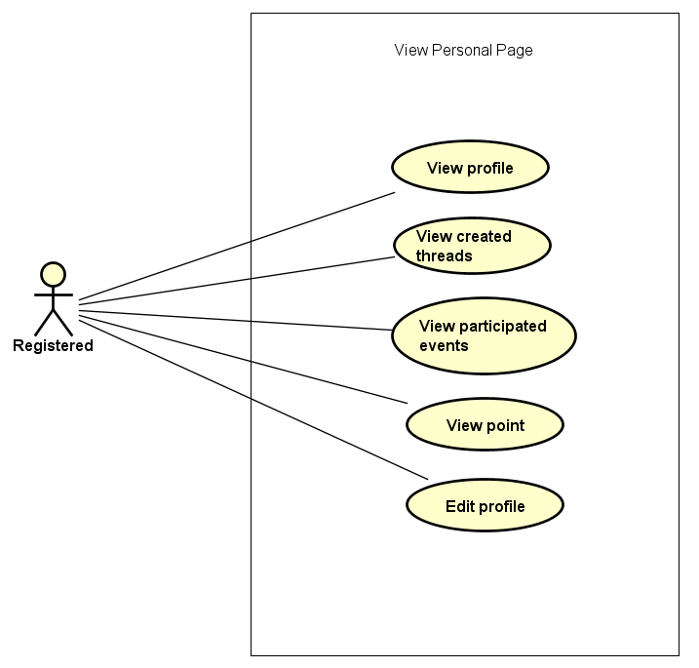

Figure 3-4: Manage Personal Information use case

##### UC016- View profile

|  |  |  |  |  |
| --- | --- | --- | --- | --- |
| **Use Case ID** | | UC016 | **Version** | 1.0 |
| **Use Case Name** | | Display user profile | | |
| **Created by:** | | DuyTN | **Date Created:** | 05/11/2016 |
| **Primary Actor** | | Registered user | **Secondary Actor** |  |
| **Priority** | | High | | |
| **Frequency of Use:** | | High | | |
| **Description:** | | WS display the information of user on user profile page | | |
| **Preconditions:** | | 1. WS website is available  2.User browsed WS website  3. User logged in to system | | |
| **Trigger:** | | User move on Avatar image icon | | |
| **Post conditions:** | | The user profile is displayed | | |
| **Normal Flow** | | | | |
| **Step** | **Actor** | **Action** | | |
| 1 | User | Click Avatar image button in header | | |
| 2 | WS | Display a menu includes:   * Message * Notification * Profile * Organization * Logout | | |
| 3 | User | Click View Profile | | |
| 4 | WS | Redirect user to Profile page includes:   * Header * User information tab * Donation tab * Thread tab * Change password tab | | |
| **Alternative Flows: N/A** | | | | |
| **Exceptions: N/A** | | | | |
| **Business Rules:** | | N/A | | |
| **Other Information:** | | N/A | | |

Table 2- 24: View profile Use case

##### UC017- View created thread

|  |  |  |  |  |
| --- | --- | --- | --- | --- |
| **Use Case ID** | | UC017 | **Version** | 1.0 |
| **Use Case Name** | | Display created event | | |
| **Created by:** | | DuyTN | **Date Created:** | 05/11/2016 |
| **Primary Actor** | | Registered user | **Secondary Actor** |  |
| **Priority** | | High | | |
| **Frequency of Use:** | | High | | |
| **Description:** | | WS records all thread which user created | | |
| **Preconditions:** | | 1. WS website is available  2.User browsed WS website  3. User logged in to system | | |
| **Trigger:** | | User move on Avatar image icon | | |
| **Post conditions:** | | All created thread is displayed | | |
| **Normal Flow** | | | | |
| **Step** | **Actor** | **Action** | | |
| 1 | User | Click Avatar image button in header | | |
| 2 | WS | Display a menu includes:   * Message * Notification * Profile * Organization * Logout | | |
| 3 | User | Click Profile | | |
| 4 | WS | Redirect user to Profile page includes:   * Header * User information tab * Donation tab * Thread tab * Change password tab | | |
| 5 | User | Click Created Thread tab | | |
| 6 | WS | Display all thread created | | |
| **Alternative Flows: N/A** | | | | |
| **Exceptions: N/A** | | | | |
| **Business Rules:** | | N/A | | |
| **Other Information:** | | N/A | | |

Table 2- 25: View Created thread Use case

##### UC018- View donated event

|  |  |  |  |  |
| --- | --- | --- | --- | --- |
| **Use Case ID** | | UC018 | **Version** | 1.0 |
| **Use Case Name** | | Display donated event | | |
| **Created by:** | | DuyTN | **Date Created:** | 05/11/2016 |
| **Primary Actor** | | Registered user | **Secondary Actor** |  |
| **Priority** | | High | | |
| **Frequency of Use:** | | High | | |
| **Description:** | | WS records all event which user donated | | |
| **Preconditions:** | | 1. WS website is available  2.User browsed WS website  3. User logged in to system | | |
| **Trigger:** | | User move on Avatar image icon | | |
| **Post conditions:** | | All donated event are displayed | | |
| **Normal Flow** | | | | |
| **Step** | **Actor** | **Action** | | |
| 1 | User | Click Avatar image button in header | | |
| 2 | WS | Display a menu includes:   * Message * Notification * Profile * Organization * Logout | | |
| 3 | User | Click Profile | | |
| 4 | WS | Redirect user to Profile page includes:   * Header * User information tab * Donation tab * Thread tab * Change password tab | | |
| 5 | User | Click on donated event tab | | |
| 6 | WS | Display all donated event | | |
| **Alternative Flows: N/A** | | | | |
| **Exceptions: N/A** | | | | |
| **Business Rules:** | | N/A | | |
| **Other Information:** | | N/A | | |

Table 2- 26: View craeted event Use case

##### UC019- View point

|  |  |  |  |  |
| --- | --- | --- | --- | --- |
| **Use Case ID** | | UC018 | **Version** | 1.0 |
| **Use Case Name** | | Display user activity point | | |
| **Created by:** | | DuyTN | **Date Created:** | 05/11/2016 |
| **Primary Actor** | | Registered user | **Secondary Actor** |  |
| **Priority** | | Normal | | |
| **Frequency of Use:** | | High | | |
| **Description:** | | WS record every user activity and base on it to point or rank each user | | |
| **Preconditions:** | | 1. WS website is available  2.User browsed WS website  3. User logged in to system | | |
| **Trigger:** | | User move on Avatar image icon | | |
| **Post conditions:** | | Display activity point of user | | |
| **Normal Flow** | | | | |
| **Step** | **Actor** | **Action** | | |
| 1 | User | Click Avatar image button in header | | |
| 2 | WS | Display a menu includes:   * Message * Notification * Profile * Organization * Logout | | |
| 3 | User | Click Profile | | |
| 4 | WS | Redirect user to Profile page includes:   * Header * User information | | |
| **Alternative Flows: N/A** | | | | |
| **Exceptions: N/A** | | | | |
| **Business Rules:** | | N/A | | |
| **Other Information:** | | N/A | | |

Table 2- 27: View activity point Use case

##### UC019- Edit profile

|  |  |  |  |  |
| --- | --- | --- | --- | --- |
| **Use Case ID** | | UC019 | **Version** | 1.0 |
| **Use Case Name** | | Edit Profile | | |
| **Created by:** | | DuyTN | **Date Created:** | 05/11/2016 |
| **Primary Actor** | | Registered user | **Secondary Actor** |  |
| **Priority** | | High | | |
| **Frequency of Use:** | | High | | |
| **Description:** | | This function allows user to edit profile | | |
| **Preconditions:** | | 1. WS website is available  2.User browsed WS website  3. User logged in to system | | |
| **Trigger:** | | User click Edit button | | |
| **Post conditions:** | | Edit profile screen is displayed | | |
| **Normal Flow** | | | | |
| **Step** | **Actor** | **Action** | | |
| 1 | User | Click Avatar image button in header | | |
| 2 | WS | Display a menu includes:   * Message * Notification * Profile * Organization * Logout | | |
| 3 | User | Click Profile | | |
| 4 | WS | Redirect user to Profile page includes:   * Header * User information | | |
| 5 | User | Click Edit profile button | | |
| 6 | WS | Some text box are enable to edit | | |
| 7 | User | Edit information and click Save button | | |
| 8 | WS | Display message successful  All information has been saved and display. All text box are disable to edit. | | |
| **Alternative Flows: N/A** | | | | |
| **Exceptions:** | | | | |
| **EC1** | At step 7 in main flow, if user do not click Save and go to other page | | | |
| **Step** | **Actor** | **Action** | | |
| 8.1 | WS | All the information which has been changed do not save | | |
| **Business Rules:** | | N/A | | |
| **Other Information:** | | N/A | | |

Table 2- 28: Edit Profile Use case

##### UC020- Change password

|  |  |  |  |  |
| --- | --- | --- | --- | --- |
| **Use Case ID** | | UC020 | **Version** | 1.1 |
| **Use Case Name** | | Change password | | |
| **Created by:** | | AnhDD | **Date Created:** | 24/09/2015 |
| **Primary Actor** | | Registered user | **Secondary Actor** |  |
| **Priority** | | Normal | | |
| **Frequency of Use:** | | Normal | | |
| **Description:** | | This function allows user to change password | | |
| **Preconditions:** | | 1. DDL website is available  2.User browsed DDL website  3. User logged in to system | | |
| **Trigger:** | | User click Change password tab | | |
| **Post conditions:** | | Password has been changed | | |
| **Normal Flow** | | | | |
| **Step** | **Actor** | **Action** | | |
| 1 | User | Click Avatar image button in header | | |
| 2 | WS | Display a menu includes:   * Message * Notification * Profile * Organization * Logout | | |
| 3 | User | Click Profile | | |
| 4 | WS | Redirect user to Profile page includes:   * Header * User information tab * Donation tab * Thread tab * Change password tab | | |
| 5 | User | Click change password tab | | |
| 6 | WS | Display change password tab | | |
| **Alternative Flows: N/A** | | | | |
| **Exceptions: N/A** | | | | |
| **Business Rules:** | | N/A | | |
| **Other Information:** | | N/A | | |

Table 2- 29: Change password

#### Message

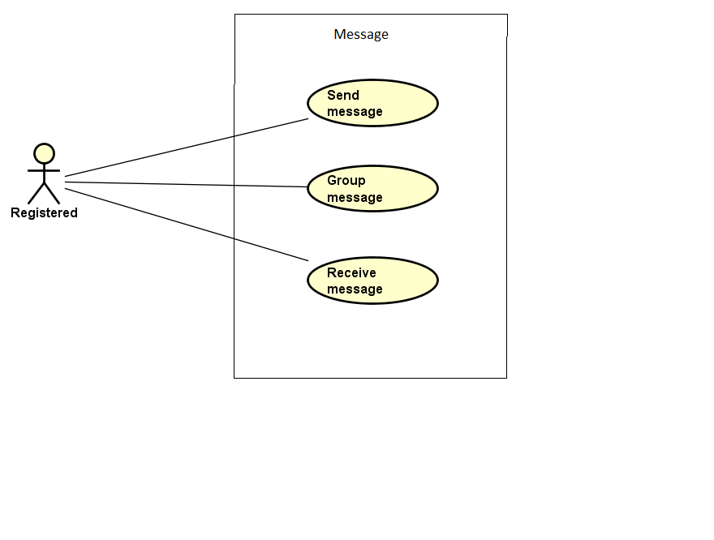

Figure 3-5: Message Modal use case

##### UC021- Group message

|  |  |  |  |  |
| --- | --- | --- | --- | --- |
| **Use Case ID** | | UC021 | **Version** | 1.0 |
| **Use Case Name** | | Group message | | |
| **Created by:** | | DuyTN | **Date Created:** | 05/11/2016 |
| **Primary Actor** | | Registered user | **Secondary Actor** |  |
| **Priority** | | Normal | | |
| **Frequency of Use:** | | High | | |
| **Description:** | | WS records all message of user | | |
| **Preconditions:** | | 1. WS website is available  2.User browsed WS website  3. User logged in to system | | |
| **Trigger:** | | User click Message then choose message type in drop box | | |
| **Post conditions:** | | List all results that matched with the message type and on screen | | |
| **Normal Flow** | | | | |
| **Step** | **Actor** | **Action** | | |
| 1 | User | Click Avatar image button in header | | |
| 2 | WS | Display a menu includes:   * Message * Notification * Profile * Organization * Logout | | |
| 3 | User | Click Message | | |
| 4 | WS | Display message page | | |
| 5 | User | Choose message type in drop box | | |
| 6 | WS | List all results that matched with the message type and on screen | | |
| **Alternative Flows: N/A** | | | | |
| **Exceptions:** | | | | |
| **EC1** | At step 5 in the main flows, if there is no result matched the message type | | | |
| **Step** | **Actor** | **Action** | | |
| 3.1 | WS | Display Nothing | | |
|  | | | | |
| **Priority** | | Normal | | |
| **Frequency of Use:** | | Normal | | |
| **Business Rules:** | | N/A | | |
| **Other Information:** | | N/A | | |

Table 2- 22: Group message Use case

##### UC022-Send Message

|  |  |  |  |  |
| --- | --- | --- | --- | --- |
| **Use Case ID** | | UC022 | **Version** | 1.0 |
| **Use Case Name** | | Send message | | |
| **Created by:** | | DuyTN | **Date Created:** | 05/11/2016 |
| **Primary Actor** | | Registered user | **Secondary Actor** |  |
| **Priority** | | High | | |
| **Frequency of Use:** | | High | | |
| **Description:** | | This function allows user to send a message | | |
| **Preconditions:** | | 1. WS website is available 2. User browsed WS website 3. User logged in to system 4. User are on message page | | |
| **Trigger:** | | User enters message and click Send | | |
| **Post conditions:** | | Message sent | | |
| **Normal Flow** | | | | |
| **Step** | **Actor** | **Action** | | |
| 1 | User | Click Avatar image button in header | | |
| 2 | WS | Display a menu includes:   * Message * Notification * Profile * Organization * Logout | | |
| 3 | User | Click Message | | |
| 4 | WS | Display message page | | |
| 5 | User | Choose 1 message of other user | | |
| 6 | WS | Display conversation of 2 user | | |
| 7 | User | Enter message and click Send or Press Enter | | |
| 8 | WS | Message send to user | | |
| **Alternative Flows:** | | | | |
| **AT1** | At step 5 in the main flows, if user enter user URL linl | | | |
| **Step** | **Actor** | **Action** | | |
| 1 | WS | Redirects user to other user profile | | |
| 2 | User | Click on Send Message button | | |
| 3 | WS | Display message pop-up | | |
| 4 | User | Write message and click Send | | |
| 5 | WS | Send message and display notification | | |
|  | | | | |
| **AT2** | At step 2 in the main flows, if user click other hyperlinks or buttons | | | |
| **Step** | **Actor** | **Action** | | |
| 2.1 | WS | Redirects user to chosen hyperlink or button | | |
|  | | | | |
| **Exceptions:** | | | | |
| **EC1** | Message can not sent | | | |
| **Step** | **Actor** | **Action** | | |
| 1 | WS | Show a dialog error | | |
|  | | | | |
| **Priority** | | High | | |
| **Frequency of Use:** | | High | | |
| **Business Rules:** | |  | | |
| **Other Information:** | | N/A | | |

##### UC023-Receive Message

|  |  |  |  |  |
| --- | --- | --- | --- | --- |
| **Use Case ID** | | UC023 | **Version** | 1.0 |
| **Use Case Name** | | Receive message | | |
| **Created by:** | | DuyTN | **Date Created:** | 05/11/2016 |
| **Primary Actor** | | Registered user | **Secondary Actor** |  |
| **Priority** | | High | | |
| **Frequency of Use:** | | High | | |
| **Description:** | | This function allows user to receive message from other user | | |
| **Preconditions:** | | 1.WS website is available  2.User browsed WS website  3.User logged in to system | | |
| **Trigger:** | | User choose a message button | | |
| **Post conditions:** | | All message is displayed | | |
| **Normal Flow** | | | | |
| **Step** | **Actor** | **Action** | | |
| 1 | User | Click Avatar image button in header | | |
| 2 | WS | Display a menu includes:   * Message * Notification * Profile * Organization * Logout | | |
| 3 | User | Click Message | | |
| 4 | WS | Display message page | | |
| 5 | User | Choose 1 of message type | | |
| 6 | WS | Display all message which has been sent from other | | |
| **Alternative Flows:** | | | | |
| **AT1** | At step 2 in the main flows, if user click other hyperlinks or buttons | | | |
| **Step** | **Actor** | **Action** | | |
| 2.1 | WS | Redirects user to chosen hyperlink or button | | |
|  | | | | |
| **Exceptions: N/A** | | | | |
| **Priority** | | High | | |
| **Frequency of Use:** | | High | | |
| **Business Rules:** | |  | | |
| **Other Information:** | | N/A | | |

Table 2- 23: Receive message Use case

#### Chat room

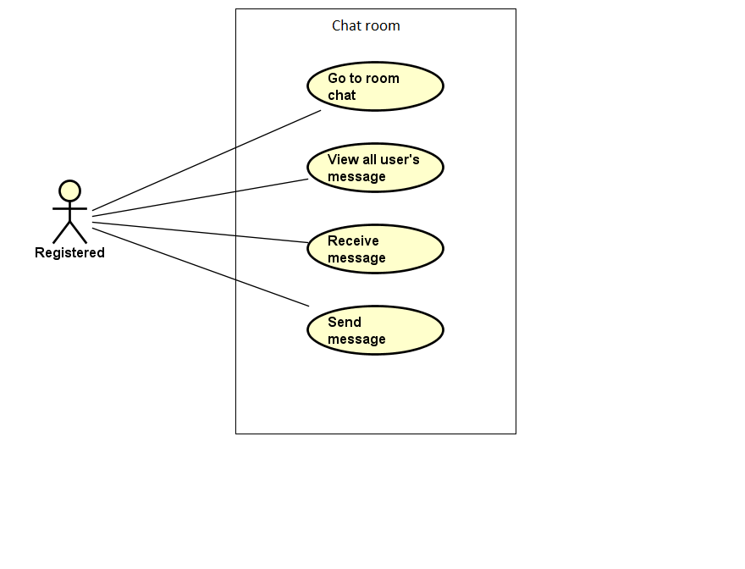

Figure 3-6: Message Modal use case

##### UC024- Go to Room chat

|  |  |  |  |  |
| --- | --- | --- | --- | --- |
| **Use Case ID** | | UC024 | **Version** | 1.0 |
| **Use Case Name** | | Enter event chat room | | |
| **Created by:** | | DuyTN | **Date Created:** | 05/11/2016 |
| **Primary Actor** | | Registered user | **Secondary Actor** |  |
| **Priority** | | High | | |
| **Frequency of Use:** | | High | | |
| **Description:** | | User enter to event chat room | | |
| **Preconditions:** | | 1. WS website is available  2.User browsed WS website  3. User logged in to system | | |
| **Trigger:** | | User click Enter chat room | | |
| **Post conditions:** | | User enter chat room | | |
| **Normal Flow** | | | | |
| **Step** | **Actor** | **Action** | | |
| 1 | User | Click on an event on homepage | | |
| 2 | WS | Redirect to event detail | | |
| 3 | User | Click on pop-up Chat and click Enter Room chat | | |
| 4 | WS | Move to event room chat and display all chat message of all user | | |
| **Alternative Flows: N/A** | | | | |
| **Exceptions:** | | | | |
| **EC1** | At step 3 in the main flows, if user cannot enter room chat | | | |
| **Step** | **Actor** | **Action** | | |
| 3.1 | WS | Display Error | | |
|  | | | | |
| **Priority** | | Normal | | |
| **Frequency of Use:** | | High | | |
| **Business Rules:** | | N/A | | |
| **Other Information:** | | N/A | | |

Table 2- 22: Enter room chat Use case

##### UC025- View all user message

|  |  |  |  |  |
| --- | --- | --- | --- | --- |
| **Use Case ID** | | UC025 | **Version** | 1.0 |
| **Use Case Name** | | View all user message before | | |
| **Created by:** | | DuyTN | **Date Created:** | 05/11/2016 |
| **Primary Actor** | | Registered user | **Secondary Actor** |  |
| **Priority** | | Normal | | |
| **Frequency of Use:** | | High | | |
| **Description:** | | User enter to event chat room | | |
| **Preconditions:** | | 1. WS website is available  2.User browsed WS website  3. User logged in to system | | |
| **Trigger:** | | User click Enter chat room | | |
| **Post conditions:** | | Display all message of users before | | |
| **Normal Flow** | | | | |
| **Step** | **Actor** | **Action** | | |
| 1 | User | Click on an event on homepage | | |
| 2 | WS | Redirect to event detail | | |
| 3 | User | Click on pop-up Chat and click Enter Room chat | | |
| 4 | WS | Move to event room chat and display all chat message of all user | | |
| **Alternative Flows** | | | | |
| **Exceptions:** | | | | |
| **EC1** | At step 3 in the main flows, if user cannot enter room chat | | | |
| **Step** | **Actor** | **Action** | | |
| 3.1 | WS | Display Error | | |
|  | | | | |
| **Priority** | | Normal | | |
| **Frequency of Use:** | | High | | |
| **Business Rules:** | | N/A | | |
| **Other Information:** | | N/A | | |

Table 2- 22: View all user message Use case

##### UC026- Receive Message

|  |  |  |  |  |
| --- | --- | --- | --- | --- |
| **Use Case ID** | | UC026 | **Version** | 1.0 |
| **Use Case Name** | | Enter event chat room | | |
| **Created by:** | | DuyTN | **Date Created:** | 05/11/2016 |
| **Primary Actor** | | Registered user | **Secondary Actor** |  |
| **Priority** | | High | | |
| **Frequency of Use:** | | High | | |
| **Description:** | | User enter to event chat room | | |
| **Preconditions:** | | 1. WS website is available  2.User browsed WS website  3. User logged in to system | | |
| **Trigger:** | | User click Enter chat room | | |
| **Post conditions:** | | User receive message when other send | | |
| **Normal Flow** | | | | |
| **Step** | **Actor** | **Action** | | |
| 1 | User | Click on an event on homepage | | |
| 2 | WS | Redirect to event detail | | |
| 3 | User | Click on pop-up Chat and click Enter Room chat | | |
| 4 | WS | Display message when other send | | |
| **Alternative Flows** | | | | |
| **Exceptions:** | | | | |
| **EC1** | At step 3 in the main flows, if user cannot enter room chat | | | |
| **Step** | **Actor** | **Action** | | |
| 3.1 | WS | Display Error | | |
|  | | | | |
| **Priority** | | Normal | | |
| **Frequency of Use:** | | High | | |
| **Business Rules:** | | N/A | | |
| **Other Information:** | | N/A | | |

Table 2- 22: Receive message Use case

##### UC027- Send Message

|  |  |  |  |  |
| --- | --- | --- | --- | --- |
| **Use Case ID** | | UC027 | **Version** | 1.0 |
| **Use Case Name** | | Enter event chat room | | |
| **Created by:** | | DuyTN | **Date Created:** | 05/11/2016 |
| **Primary Actor** | | Registered user | **Secondary Actor** |  |
| **Priority** | | High | | |
| **Frequency of Use:** | | High | | |
| **Description:** | | User enter to event chat room | | |
| **Preconditions:** | | 1. WS website is available  2.User browsed WS website  3. User logged in to system | | |
| **Trigger:** | | User click Enter chat room | | |
| **Post conditions:** | | Message has been sent and display on room chat | | |
| **Normal Flow** | | | | |
| **Step** | **Actor** | **Action** | | |
| 1 | User | Click on an event on homepage | | |
| 2 | WS | Redirect to event detail | | |
| 3 | User | Click on pop-up Chat and click Enter Room chat | | |
| 4 | WS | Move to event room chat and display all chat message of all user | | |
| 5 | User | Write message and click Send (Or press Enter) | | |
| 6 | WS | Send message and display on room chat pop-up | | |
| **Alternative Flows** | | | | |
| **Exceptions:** | | | | |
| **EC1** | At step 3 in the main flows, if user cannot enter room chat | | | |
| **Step** | **Actor** | **Action** | | |
| 3.1 | WS | Display Error | | |
|  | | | | |
| **Priority** | | High | | |
| **Frequency of Use:** | | High | | |
| **Business Rules:** | | N/A | | |
| **Other Information:** | | N/A | | |

Table 2- 22: Send message Use case

#### Like

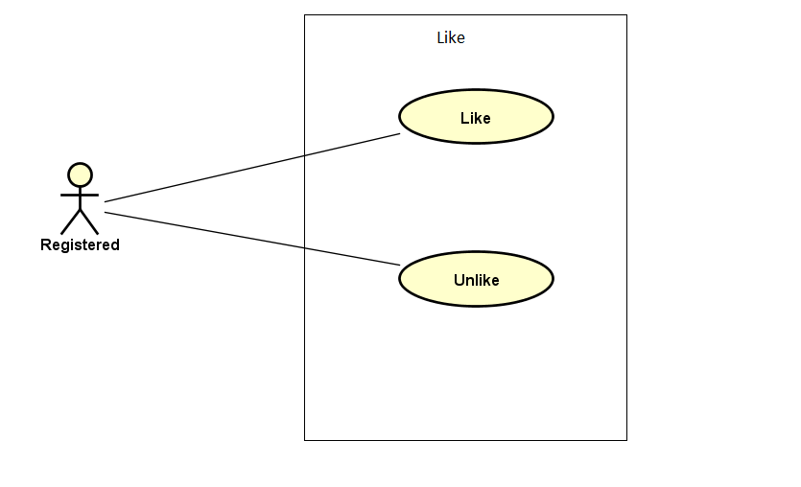

Figure 3-7: Like use case

##### UC028- Like

|  |  |  |  |  |
| --- | --- | --- | --- | --- |
| **Use Case ID** | | UC028 | **Version** | 1.0 |
| **Use Case Name** | | Like comment or thread | | |
| **Created by:** | | DuyTN | **Date Created:** | 05/11/2016 |
| **Primary Actor** | | Registered user | **Secondary Actor** |  |
| **Priority** | | Normal | | |
| **Frequency of Use:** | | High | | |
| **Description:** | | User like an comment or thread which they interested | | |
| **Preconditions:** | | 1. WS website is available  2. User browsed WS website  3. User logged in to system | | |
| **Trigger:** | | User click like | | |
| **Post conditions:** | | Event or thread has been liked | | |
| **Normal Flow** | | | | |
| **Step** | **Actor** | **Action** | | |
| 1 | User | Click on an event or thread | | |
| 2 | WS | Go to event or thread information detail page | | |
| 3 | User | Like | | |
| 4 | WS | Show like number | | |
| **Alternative Flows: N/A** | | | | |
| **Exceptions: N/A** | | | | |
| **Priority** | | Normal | | |
| **Frequency of Use:** | | High | | |
| **Business Rules:** | | N/A | | |
| **Other Information:** | | N/A | | |

Table 2- 38: Like Use case

##### UC029- Unlike

|  |  |  |  |  |
| --- | --- | --- | --- | --- |
| **Use Case ID** | | UC029 | **Version** | 1.0 |
| **Use Case Name** | | Unlike comment or thread | | |
| **Created by:** | | DuyTN | **Date Created:** | 05/11/2016 |
| **Primary Actor** | | Registered user | **Secondary Actor** |  |
| **Priority** | | Normal | | |
| **Frequency of Use:** | | High | | |
| **Description:** | | User like an comment or thread which they interested | | |
| **Preconditions:** | | 1. WS website is available  2. User browsed WS website  3. User logged in to system | | |
| **Trigger:** | | User click like (already liked this before) | | |
| **Post conditions:** | | Event or thread has been unliked | | |
| **Normal Flow** | | | | |
| **Step** | **Actor** | **Action** | | |
| 1 | User | Click on an event or thread | | |
| 2 | WS | Go to event or thread information detail page | | |
| 3 | User | Click on like button (already like it before) | | |
| 4 | WS | Unlike this event or thread | | |
| **Alternative Flows: N/A** | | | | |
| **Exceptions: N/A** | | | | |
| **Priority** | | Normal | | |
| **Frequency of Use:** | | High | | |
| **Business Rules:** | | N/A | | |
| **Other Information:** | | N/A | | |

Table 2- 38: Like Use case

#### Comment

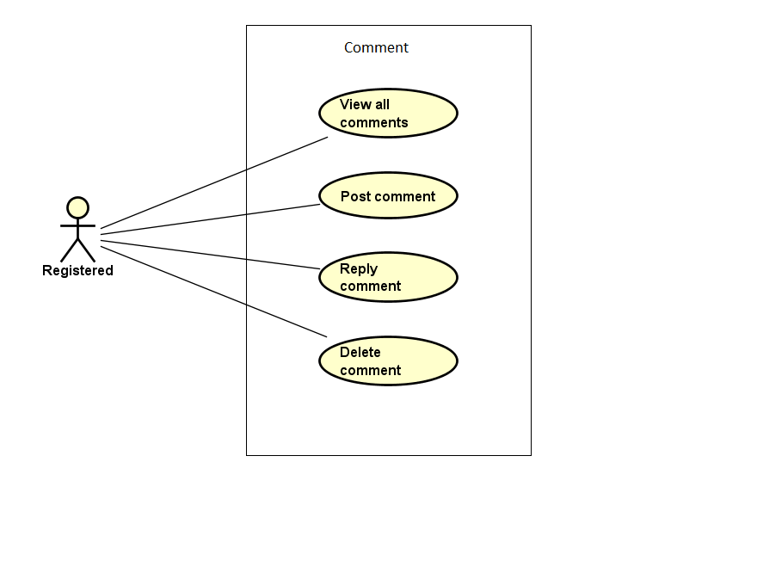

Figure 3-8: Comment use case

##### UC024- View all comment

|  |  |  |  |  |
| --- | --- | --- | --- | --- |
| **Use Case ID** | | UC024 | **Version** | 1.0 |
| **Use Case Name** | | View list comment | | |
| **Created by:** | | DuyTN | **Date Created:** | 05/11/2016 |
| **Primary Actor** | | Registered user | **Secondary Actor** |  |
| **Priority** | | High | | |
| **Frequency of Use:** | | High | | |
| **Description:** | | WS show all comment of an event or thread | | |
| **Preconditions:** | | 1. WS website is available  2. User browsed WS website  3. User logged in to system | | |
| **Trigger:** | | User click on event or thread detail | | |
| **Post conditions:** | | Comment is displayed | | |
| **Normal Flow** | | | | |
| **Step** | **Actor** | **Action** | | |
| 1 | User | Click on an event or thread | | |
| 2 | WS | Go to event or thread detail page | | |
| 3 | User | Scroll down to comment area | | |
| 4 | WS | Display list comment | | |
| **Alternative Flows: N/A** | | | | |
| **Exceptions: N/A** | | | | |
| **Priority** | | High | | |
| **Frequency of Use:** | | High | | |
| **Business Rules:** | | N/A | | |
| **Other Information:** | | N/A | | |

Table 2- 38: View all comment Use case

##### UC025- Post comment

|  |  |  |  |  |
| --- | --- | --- | --- | --- |
| **Use Case ID** | | UC025 | **Version** | 1.0 |
| **Use Case Name** | | Post comment | | |
| **Created by:** | | DuyTN | **Date Created:** | 05/11/2016 |
| **Primary Actor** | | Registered user | **Secondary Actor** |  |
| **Priority** | | High | | |
| **Frequency of Use:** | | High | | |
| **Description:** | | User post a comment | | |
| **Preconditions:** | | 1. WS website is available  2. User browsed WS website  3. User logged in to system | | |
| **Trigger:** | | User click on event or thread | | |
| **Post conditions:** | | Comment area is displayed | | |
| **Normal Flow** | | | | |
| **Step** | **Actor** | **Action** | | |
| 1 | User | Click on an event or thread | | |
| 2 | WS | Go to event or thread detail page | | |
| 3 | User | Scroll down to comment area | | |
| 4 | WS | Display list comment | | |
| 5 | User | Fill the comment text box then click post | | |
| 6 | WS | Post the user comment | | |
| **Alternative Flows: N/A** | | | | |
| **Exceptions: N/A** | | | | |
| **Priority** | | High | | |
| **Frequency of Use:** | | High | | |
| **Business Rules:** | | N/A | | |
| **Other Information:** | | N/A | | |

Table 2- 39: Post comment Use case

##### UC026- Reply comment

|  |  |  |  |  |
| --- | --- | --- | --- | --- |
| **Use Case ID** | | UC026 | **Version** | 1.0 |
| **Use Case Name** | | Edit comment | | |
| **Created by:** | | DuyTN | **Date Created:** | 05/11/2016 |
| **Primary Actor** | | Registered user | **Secondary Actor** |  |
| **Priority** | | Normal | | |
| **Frequency of Use:** | | High | | |
| **Description:** | | User edit comment | | |
| **Preconditions:** | | 1. WS website is available  2. User browsed WS website  3. User logged in to system  4. User clicked on a event | | |
| **Trigger:** | | User click on comment tab in event information page | | |
| **Post conditions:** | | Comment tab is displayed | | |
| **Normal Flow** | | | | |
| **Step** | **Actor** | **Action** | | |
| 1 | User | Click on an event or thread | | |
| 2 | WS | Go to event or thread detail page | | |
| 3 | User | Scroll down to comment area | | |
| 4 | WS | Display list comment | | |
| 5 | User | Choose a comment which want to reply and click Reply | | |
| 6 | WS | Show comment text box | | |
| 7 | User | Write the reply in text box and press Enter | | |
| 8 | WS | Display the comment as reply comment | | |
| **Alternative Flows: N/A** | | | | |
| **Exceptions: N/A** | | | | |
| **Priority** | | High | | |
| **Frequency of Use:** | | High | | |
| **Business Rules:** | | N/A | | |
| **Other Information:** | | N/A | | |

Table 2- 40: Registered user Use case

##### UC027- Delete comment

|  |  |  |  |  |
| --- | --- | --- | --- | --- |
| **Use Case ID** | | UC027 | **Version** | 1.0 |
| **Use Case Name** | | Delete comment | | |
| **Created by:** | | DuyTN | **Date Created:** | 05/11/2016 |
| **Primary Actor** | | Registered user | **Secondary Actor** |  |
| **Priority** | | Normal | | |
| **Frequency of Use:** | | Normal | | |
| **Description:** | | User edit comment | | |
| **Preconditions:** | | 1. WS website is available  2. User browsed WS website  3. User logged in to system | | |
| **Trigger:** | | User click on thread or event detail page | | |
| **Post conditions:** | | Comment area is displayed | | |
| **Normal Flow** | | | | |
| **Step** | **Actor** | **Action** | | |
| 1 | User | Click on an event or thread | | |
| 2 | WS | Go to event or thread detail page | | |
| 3 | User | Scroll down to comment area | | |
| 4 | WS | Display list comment | | |
| 5 | User | Click on own comment and click delete | | |
| 6 | WS | Delete the comment | | |
| **Alternative Flows: N/A** | | | | |
| **Exceptions: N/A** | | | | |
| **Priority** | | High | | |
| **Frequency of Use:** | | High | | |
| **Business Rules:** | | N/A | | |
| **Other Information:** | | N/A | | |

Table 2- 41: Delete comment Use case

#### Manage Event

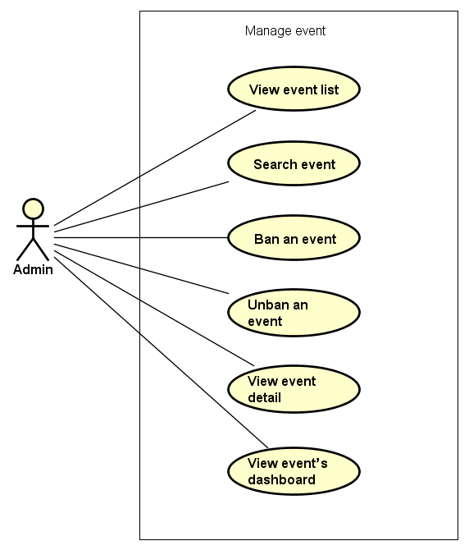

Figure 3-9: Manage event use case

##### UC028- Edit Event

|  |  |  |  |  |
| --- | --- | --- | --- | --- |
| **Use Case ID** | | UC028 | **Version** | 1.0 |
| **Use Case Name** | | Edit Event | | |
| **Created by:** | | DuyTN | **Date Created:** | 05/11/2016 |
| **Primary Actor** | | Registered user | **Secondary Actor** |  |
| **Priority** | | High | | |
| **Frequency of Use:** | | High | | |
| **Description:** | | This function allows user to edit Event | | |
| **Preconditions:** | | 1. WS website is available  2.User browsed WS website  3. User logged in to system | | |
| **Trigger:** | | User click Edit | | |
| **Post conditions:** | | Edit event Page is displayed | | |
| **Normal Flow** | | | | |
| **Step** | **Actor** | **Action** | | |
| 1 | User | Choose a event what user’s own | | |
| 2 | User | Click edit | | |
| 3 | User | Edit information | | |
| 4 | User | Click save | | |
| 5 | WS | Save change | | |
| **Alternative Flows: N/A** | | | | |
| **Exceptions:** | | | | |
| **EC1** | At step 3 in the main flows, if user miss fill 1 or more information | | | |
| **Step** | **Actor** | **Action** | | |
| 3.1 | WS | Display Dialog to remind user | | |
|  | | | | |
| **Priority** | | High | | |
| **Frequency of Use:** | | High | | |
| **Business Rules:** | | N/A | | |
| **Other Information:** | | N/A | | |

Table 2- 42: Edit Event Use case

##### UC029-View list donor

|  |  |  |  |  |
| --- | --- | --- | --- | --- |
| **Use Case ID** | | UC029 | **Version** | 1.0 |
| **Use Case Name** | | View list donor | | |
| **Created by:** | | DuyTN | **Date Created:** | 05/11/2016 |
| **Primary Actor** | | Registered user | **Secondary Actor** |  |
| **Priority** | | High | | |
| **Frequency of Use:** | | High | | |
| **Description:** | | This function allows user to edit Event | | |
| **Preconditions:** | | 1. WS website is available  2.User browsed WS website  3. User logged in to system | | |
| **Trigger:** | | User click list backer tab | | |
| **Post conditions:** | | Event information page is displayed | | |
| **Normal Flow** | | | | |
| **Step** | **Actor** | **Action** | | |
| 1 | User | Choose a event what user’s own | | |
| 2 | User | Click on list donor tab | | |
| 3 | WS | Show list donor table | | |
| **Alternative Flows: N/A** | | | | |
| **Exceptions: N/A** | | | | |
| **Priority** | | High | | |
| **Frequency of Use:** | | High | | |
| **Business Rules:** | | N/A | | |
| **Other Information:** | | N/A | | |

Table 2- 43: View list backer Use case

### **Administrator Group Function**

#### Common module

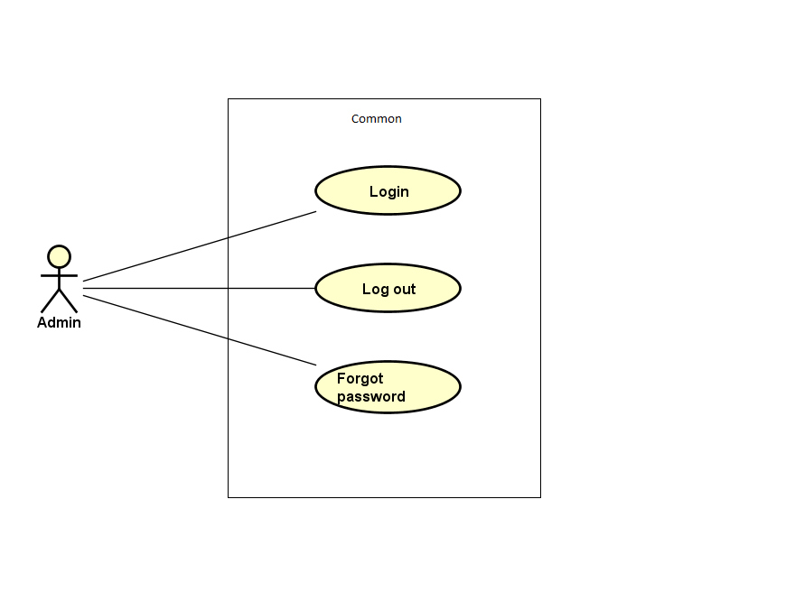

Figure 3-10: Admin common module use case

##### UC032- Admin login

|  |  |  |  |  |  |
| --- | --- | --- | --- | --- | --- |
| **Use Case ID** | | UC032 | **Version** | 1.0 | |
| **Use Case Name** | | Admin login | | | |
| **Created by:** | | DuyTN | **Date Created:** | 11/11/2016 | |
| **Primary Actor** | | Administrator(Admin) | **Secondary Actor** |  | |
| **Priority** | | High | | | |
| **Frequency of Use:** | | High | | | |
| **Description:** | | This function allows Admin logins into website | | | |
| **Preconditions:** | | 1. WS website is available  2. Admin browsed WS website | | | |
| **Trigger:** | | Admin clicks on Login button | | | |
| **Post conditions:** | | 1. Log Admin into system 2. Redirect Admin to Admin home page | | | |
| **Normal Flow** | | | | | |
| **Step** | **Actor** | **Action** | | | |
| 1 | Admin | Enter URL link: wings.com/Admin | | | |
| 2 | WS | Display Admin Login page. | | | |
| 3 | Admin | Type username and password | | | |
| 4 | WS | Verify:   * 1. Email address   2. Password | | | |
| 5 | WS | * Log Admin into system * Redirect Admin to Admin home page | | | |
| **Alternative Flows: N/A** | | | | | |
| **Exceptions:** | | | | | |
| **EC1** | At step 3 in main flow, if Admin entered wrong UserName or Password | | | |
| **Step** | **Actor** | **Action** | | |
| 2.1 | WS | Display warning error access failed | | |
| **Business Rules:** | | N/A | | | |
| **Other Information:** | | N/A | | | |

Table 2- 45: Admin login Use case

##### UC033- Admin logout

|  |  |  |  |  |
| --- | --- | --- | --- | --- |
| **Use Case ID** | | UC033 | **Version** | 1.0 |
| **Use Case Name** | | Admin logout | | |
| **Created by:** | | DuyTN | **Date Created:** | 11/11/2016 |
| **Primary Actor** | | Administrator(Admin) | **Secondary Actor** |  |
| **Priority** | | High | | |
| **Frequency of Use:** | | High | | |
| **Description:** | | This function allows Admin logouts of WS website | | |
| **Preconditions:** | | Admin logged in WS website as Administrator | | |
| **Trigger:** | | Admin clicks on Logout | | |
| **Post conditions:** | | Admin is logged out from WS website | | |
| **Normal Flow** | | | | |
| **Step** | **Actor** | **Action** | | |
| 1 | Admin | * Click on dropdown at right side of WS website * Choose Logout option | | |
| 2 | WS | * Logout Admin * Redirect to Admin Login page | | |
| **Alternative Flows:N/A** | | | | |
| **Exceptions: N/A** | | | | |
| **Business Rules:** | | N/A | | |
| **Other Information:** | | N/A | | |

Table 2- 46: Admin logout Use case

##### UC034- Admin forgot password

|  |  |  |  |  |  |
| --- | --- | --- | --- | --- | --- |
| **Use Case ID** | | UC034 | **Version** | 1.0 | |
| **Use Case Name** | | Admin forgot password | | | |
| **Created by:** | | DuyTN | **Date Created:** | 11/11/2016 | |
| **Primary Actor** | | Administrator(Admin) | **Secondary Actor** |  | |
| **Priority** | | Normal | | | |
| **Frequency of Use:** | | Normal | | | |
| **Description:** | | This function allows Admin receiving her/ his password to email | | | |
| **Preconditions:** | | 1. WS website is available 2. Admin browsed WS website | | | |
| **Trigger:** | | Click Forgot password in Login page | | | |
| **Post conditions:** | | Admin get new password on her/ his email | | | |
| **Normal Flow** | | | | | |
| **Step** | **Actor** | **Action** | | | |
| 1 | Admin | Click Forgot password in Login page | | |
| 2 | WS | Display Email text box | | |
| 3 | Admin | Enter registered email | | |
| 4 | Admin | Click Get Password | | |
| 5 | WS | Sends confirm email | | |
| 6 | WS | Redirect to guest homepage | | |
| **Alternative Flows:** | | | | |
| **AT1** | At step 3 in the main flows, if Admin click other hyperlinks or buttons | | | |
| **Step** | **Actor** | **Action** | | |
| 3.1 | WS | Redirects Admin to chosen hyperlink or button | | |
|  | | | | |
| **Exceptions:** | | | | |
| **EC1** | At step 3, mail input is invalid | | | |
| **Step** | **Actor** | **Action** | | |
| 3.1 | WS | Displays warning message | | |
| **Business Rules:** | | N/A | | |
| **Other Information:** | | N/A | | |

Table 2- 47: Admin forgot password Use case

#### Manage user's account

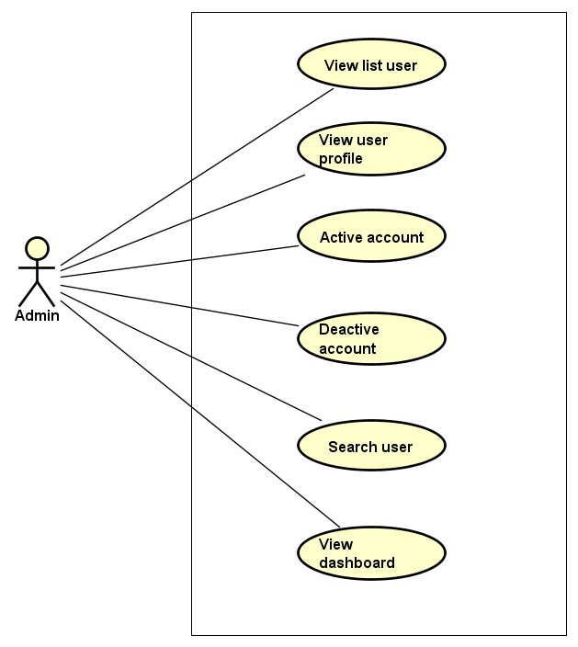

Figure 3-11: Manage user account use case

##### UC035- View list user

|  |  |  |  |  |
| --- | --- | --- | --- | --- |
| **Use Case ID** | | UC035 | **Version** | 1.0 |
| **Use Case Name** | | View user list | | |
| **Created by:** | | DuyTN | **Date Created:** | 11/11/2016 |
| **Primary Actor** | | Administrator(Admin) | **Secondary Actor** |  |
| **Priority** | | High | | |
| **Frequency of Use:** | | High | | |
| **Description:** | | This function allows Administrator to view User list of who has registered. | | |
| **Preconditions:** | | 1. WS website is available 2. Admin browsed WS website 3. Admin logged in as Administrator | | |
| **Trigger:** | | Admin clicks on Users List | | |
| **Post conditions:** | | Users List is displayed | | |
| **Normal Flow** | | | | |
| **Step** | **Actor** | **Action** | | |
| 1 | Admin | * Click on Users at left side * Click on Users List | | |
| 2 | WS | Display list of users | | |
| **Alternative Flows:** | | | | |
| **AT1** | At step 1 in the main flows, if do not have any user | | | |
| **Step** | **Actor** | **Action** | | |
| 2.1 | WS | Display “Do not have any user” message | | |
| **Exceptions: N/A** | | | | |
| **Business Rules:** | | N/A | | |
| **Other Information:** | | N/A | | |

Table 2- 48: View user list Use case

##### UC036- View user profile

|  |  |  |  |  |
| --- | --- | --- | --- | --- |
| **Use Case ID** | | UC036 | **Version** | 1.0 |
| **Use Case Name** | | View user profile | | |
| **Created by:** | | DuyTN | **Date Created:** | 11/11/2016 |
| **Primary Actor** | | Administrator(Admin) | **Secondary Actor** |  |
| **Priority** | | High | | |
| **Frequency of Use:** | | High | | |
| **Description:** | | This function allows Administrator to view profile of an user | | |
| **Preconditions:** | | Admin is viewing Users List | | |
| **Trigger:** | | Admin clicks on View button | | |
| **Post conditions:** | | Profile of this user is displayed | | |
| **Normal Flow** | | | | |
| **Step** | **Actor** | **Action** | | |
| 1 | Admin | Click on View detail button at Action column of the user whom want to see profile | | |
| 2 | WS | Display profile of this user | | |
| **Alternative Flows: N/A** | | | | |
| **Exceptions: N/A** | | | | |
| **Business Rules:** | | N/A | | |
| **Other Information:** | | N/A | | |

Table 2- 49: View user profile Use case

##### UC037- Activate user's account

|  |  |  |  |  |
| --- | --- | --- | --- | --- |
| **Use Case ID** | | UC037 | **Version** | 1.0 |
| **Use Case Name** | | Activate user's account | | |
| **Created by:** | | DuyTN | **Date Created:** | 11/11/2016 |
| **Primary Actor** | | Administrator(Admin) | **Secondary Actor** |  |
| **Priority** | | High | | |
| **Frequency of Use:** | | High | | |
| **Description:** | | This function allows Administrator to activate an user’s account | | |
| **Preconditions:** | | * Admin is viewing Users List * Status of this user is deactivate | | |
| **Trigger:** | | Admin clicks on Deactivate button on status column | | |
| **Post conditions:** | | User’s account is activated | | |
| **Normal Flow** | | | | |
| **Step** | **Actor** | **Action** | | |
| 1 | Admin | Click on Deactivate button at Status column of the user whom want to activate | | |
| 2 | WS | Display pop-up confirm change status | | |
| 3 | Admin | Confirm and click YES | | |
| 4 | WS | * Change displayed status from Deactivate to Activate * Change status of this user’s account to Activate on database * Display message success | | |
| 5 | Admin | Click OK | | |
| 6 | WS | Close pop-up | | |
| **Alternative Flows:** | | | | |
| **AT1** | At step 3 in the main flows, if Admin click NO | | | |
| **Step** | **Actor** | **Action** | | |
| 3.1 | WS | Display “Cancel Action” message and Status doesn’t chage | | |
| 3.2 | Admin | Click OK | | |
| 3.3 | WS | Close pop-up | | |
| **Exceptions: N/A** | | | | |
| **Business Rules:** | | N/A | | |
| **Other Information:** | | N/A | | |

Table 2- 50: Activate user's account Use case

##### UC038- Deactivate user's account

|  |  |  |  |  |
| --- | --- | --- | --- | --- |
| **Use Case ID** | | UC038 | **Version** | 1.0 |
| **Use Case Name** | | Deactivate user's account | | |
| **Created by:** | | DuyTN | **Date Created:** | 11/11/2016 |
| **Primary Actor** | | Administrator(Admin) | **Secondary Actor** |  |
| **Priority** | | High | | |
| **Frequency of Use:** | | High | | |
| **Description:** | | This function allows Administrator to deactivate an user’s account | | |
| **Preconditions:** | | * Admin is viewing Users List * Status of this user is activate | | |
| **Trigger:** | | Admin clicks on Active button on status column | | |
| **Post conditions:** | | User’s account is deactivated | | |
| **Normal Flow** | | | | |
| **Step** | **Actor** | **Action** | | |
| 1 | Admin | Click on Active button at Status column of the user whom want to activate | | |
| 2 | WS | Display pop-up confirm change status | | |
| 3 | Admin | Confirm and click YES | | |
| 4 | WS | * Change displayed status from Active to Deactive * Change status of this user’s account to Deactive on database * Display message success | | |
| 5 | Admin | * Click OK | | |
| 6 | WS | * Close pop-up | | |
| **Alternative Flows** | | | | |
| **AT1** | At step 3 in the main flows, if Admin click NO | | | |
| **Step** | **Actor** | **Action** | | |
| 3.1 | WS | Display “Cancel Action” message and Status doesn’t chage | | |
| 3.2 | Admin | Click OK | | |
| 3.3 | WS | Close pop-up | | |
|  | | | | |
| **Exceptions: N/A** | | | | |
| **Business Rules:** | | N/A | | |
| **Other Information:** | | N/A | | |

Table 2- 51: Deactivate user's account Use case

##### UC039- Search user's account

|  |  |  |  |  |
| --- | --- | --- | --- | --- |
| **Use Case ID** | | UC039 | **Version** | 1.0 |
| **Use Case Name** | | Search user's account | | |
| **Created by:** | | DuyTN | **Date Created:** | 11/11/2016 |
| **Primary Actor** | | Administrator(Admin) | **Secondary Actor** |  |
| **Priority** | | High | | |
| **Frequency of Use:** | | High | | |
| **Description:** | | This function allows Administrator to search an user’s account | | |
| **Preconditions:** | | Admin is viewing Users List | | |
| **Trigger:** | | Admin types name of user at Search textbox | | |
| **Post conditions:** | | Display list of searched user | | |
| **Normal Flow** | | | | |
| **Step** | **Actor** | **Action** | | |
| 1 | Admin | * Type keyword of user whom want to search | | |
| 2 | WS | * Display list of users who have the name is typed | | |
| **Alternative Flows:** | | | | |
| **F** | At step 1 in the main flows, if the typed name is not exist | | | |
| **Step** | **Actor** | **Action** | | |
| 2.1 | WS | Display “No matching records found” message | | |
|  | | | | |
| **Exceptions: N/A** | | | | |
| **Business Rules:** | | N/A | | |
| **Other Information:** | | N/A | | |

Table 2- 52: Search user's account Use case

##### UC041- View user’s dashboard

|  |  |  |  |  |
| --- | --- | --- | --- | --- |
| **Use Case ID** | | UC041 | **Version** | 1.0 |
| **Use Case Name** | | View user’s dashboard | | |
| **Created by:** | | DuyTN | **Date Created:** | 11/11/2016 |
| **Primary Actor** | | Administrator(Admin) | **Secondary Actor** |  |
| **Priority** | | High | | |
| **Frequency of Use:** | | High | | |
| **Description:** | | This function allows Administrator to view dashboard about user of the event | | |
| **Preconditions:** | | 1. WS website is available 2. Admin browsed WS website 3. Admin logged in as Administrator | | |
| **Trigger:** | | Admin clicks on Dashboard | | |
| **Post conditions:** | | Dashboard about user is displayed | | |
| **Normal Flow** | | | | |
| **Step** | **Actor** | **Action** | | |
| 1 | Admin | * Click on Users at left side * Click on Dashboard | | |
| 2 | WS | Display User Dashboard page | | |
| **Alternative Flows: N/A** | | | | |
| **Exceptions: N/A** | | | | |
| **Business Rules:** | | N/A | | |
| **Other Information:** | | N/A | | |

Table 2- 54: View user’s dashboard Use case

#### Manage event



Figure 3-12: Manage event use case

##### UC042- View event list

|  |  |  |  |  |
| --- | --- | --- | --- | --- |
| **Use Case ID** | | UC042 | **Version** | 1.0 |
| **Use Case Name** | | View event list | | |
| **Created by:** | | DuyTN | **Date Created:** | 11/11/2016 |
| **Primary Actor** | | Administrator(Admin) | **Secondary Actor** |  |
| **Priority** | | High | | |
| **Frequency of Use:** | | High | | |
| **Description:** | | This function allows Administrator to view event list of the event | | |
| **Preconditions:** | | 1. WS website is available 2. Admin browsed WS website 3. Admin logged in as Administrator | | |
| **Trigger:** | | Admin clicks on Events List | | |
| **Post conditions:** | | Event List is displayed | | |
| **Normal Flow** | | | | |
| **Step** | **Actor** | **Action** | | |
| 1 | Admin | * Click on Event at left side * Click on Events List | | |
| 2 | WS | Display list of events | | |
| **Alternative Flows:** | | | | |
| **AT1** | At step 1 in the main flows, if do not have any event | | | |
| **Step** | **Actor** | **Action** | | |
| 2.1 | WS | Display “Do not have any event” message | | |
| **Exceptions: N/A** | | | | |
| **Business Rules:** | | N/A | | |
| **Other Information:** | | N/A | | |

Table 2- 55: View event list Use case

##### UC043- Search event

|  |  |  |  |  |
| --- | --- | --- | --- | --- |
| **Use Case ID** | | UC043 | **Version** | 1.0 |
| **Use Case Name** | | Search event | | |
| **Created by:** | | DuyTN | **Date Created:** | 11/11/2016 |
| **Primary Actor** | | Administrator(Admin) | **Secondary Actor** |  |
| **Priority** | | High | | |
| **Frequency of Use:** | | High | | |
| **Description:** | | This function allows Administrator to search an event | | |
| **Preconditions:** | | Admin is viewing Event List | | |
| **Trigger:** | | Admin types name of event on Search textbox | | |
| **Post conditions:** | | Display list of searched event | | |
| **Normal Flow** | | | | |
| **Step** | **Actor** | **Action** | | |
| 1 | Admin | * Type name of event which want to search | | |
| 2 | WS | * Display list of event which have the name is typed | | |
| **Alternative Flows:** | | | | |
| **AT1** | At step 1 in the main flows, if the typed name is not exist | | | |
| **Step** | **Actor** | **Action** | | |
| 2.1 | WS | Display “No matching records found” message | | |
| **Exceptions: N/A** | | | | |
| **Business Rules:** | | B1 | | |
| **Other Information:** | | N/A | | |

Table 2- 56: Search event Use case

##### UC044- Ban Event

|  |  |  |  |  |
| --- | --- | --- | --- | --- |
| **Use Case ID** | | UC044 | **Version** | 1.0 |
| **Use Case Name** | | Ban event | | |
| **Created by:** | | DuyTN | **Date Created:** | 11/11/2016 |
| **Primary Actor** | | Administrator(Admin) | **Secondary Actor** |  |
| **Priority** | | High | | |
| **Frequency of Use:** | | High | | |
| **Description:** | | This function allows Administrator to ban an event | | |
| **Preconditions:** | | Admin is viewing Event List and chosen event is not be banned | | |
| **Trigger:** | | Admin clicks on button Ban | | |
| **Post conditions:** | | Event has been banned | | |
| **Normal Flow** | | | | |
| **Step** | **Actor** | **Action** | | |
| 1 | Admin | Admin clicks on button ban at Action column | | |
| 2 | WS | Ban the chosen event | | |
| **Alternative Flows: N/A** | | | | |
| **Exceptions: N/A** | | | | |
| **Business Rules:** | | N/A | | |
| **Other Information:** | | N/A | | |

Table 2- 57: Ban event Use case

##### UC045- Unban Event

|  |  |  |  |  |
| --- | --- | --- | --- | --- |
| **Use Case ID** | | UC045 | **Version** | 1.0 |
| **Use Case Name** | | Unban event | | |
| **Created by:** | | DuyTN | **Date Created:** | 11/11/2016 |
| **Primary Actor** | | Administrator(Admin) | **Secondary Actor** |  |
| **Priority** | | High | | |
| **Frequency of Use:** | | High | | |
| **Description:** | | This function allows Administrator to ban an event | | |
| **Preconditions:** | | Admin is viewing Event List and chosen event is not be banned | | |
| **Trigger:** | | Admin clicks on button Ban | | |
| **Post conditions:** | | Event has been banned | | |
| **Normal Flow** | | | | |
| **Step** | **Actor** | **Action** | | |
| 1 | Admin | Admin clicks on button ban at Action column | | |
| 2 | WS | Ban the chosen event | | |
| **Alternative Flows: N/A** | | | | |
| **Exceptions: N/A** | | | | |
| **Business Rules:** | | N/A | | |
| **Other Information:** | | N/A | | |

Table 2- 58: Unban event Use case

##### UC046- View event detail

|  |  |  |  |  |
| --- | --- | --- | --- | --- |
| **Use Case ID** | | UC046 | **Version** | 1.0 |
| **Use Case Name** | | View event detail | | |
| **Created by:** | | DuyTN | **Date Created:** | 11/11/2016 |
| **Primary Actor** | | Administrator(Admin) | **Secondary Actor** |  |
| **Priority** | | High | | |
| **Frequency of Use:** | | High | | |
| **Description:** | | This function allows Administrator to suspend a event | | |
| **Preconditions:** | | * Admin is viewing Event List * Status of this Event is Approve | | |
| **Trigger:** | | Admin clicks on button at Status column | | |
| **Post conditions:** | | This event is suspended | | |
| **Normal Flow** | | | | |
| **Step** | **Actor** | **Action** | | |
| 1 | Admin | Click on button at Status column of the event which want to suspend | | |
| 2 | WS | * Change displayed status to Suspend * Change status of this user’s account to Suspend on database | | |
| **Alternative Flows: N/A** | | | | |
| **Exceptions: N/A** | | | | |
| **Business Rules:** | | B1 | | |
| **Other Information:** | | N/A | | |

Table 2- 59: View event Use case

##### UC048- View event dashboard

|  |  |  |  |  |
| --- | --- | --- | --- | --- |
| **Use Case ID** | | UC048 | **Version** | 1.0 |
| **Use Case Name** | | View event dashboard | | |
| **Created by:** | | DuyTN | **Date Created:** | 11/11/2016 |
| **Primary Actor** | | Administrator(Admin) | **Secondary Actor** |  |
| **Priority** | | High | | |
| **Frequency of Use:** | | High | | |
| **Description:** | | This function allows Administrator to view dashboard of event | | |
| **Preconditions:** | | 1. WS website is available 2. Admin browsed WS website 3. Admin logged in as Administrator | | |
| **Trigger:** | | Admin clicks on Dashboard | | |
| **Post conditions:** | | Dashboard about event is displayed | | |
| **Normal Flow** | | | | |
| **Step** | **Actor** | **Action** | | |
| 1 | Admin | * Click on Event at left side * Click on Dashboard | | |
| 2 | WS | Display Event Dashboard page | | |
| **Alternative Flows: N/A** | | | | |
| **Exceptions: N/A** | | | | |
| **Business Rules:** | | N/A | | |
| **Other Information:** | | N/A | | |

Table 2- 61: View event’s dashboard Use case

#### Manage thread

#### Manage donate

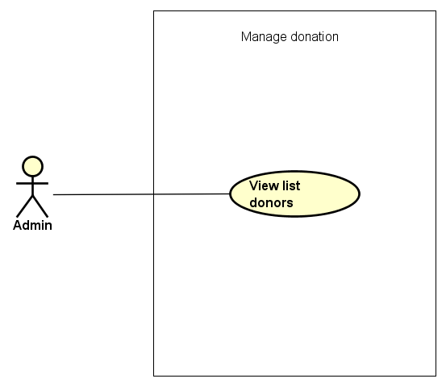

Figure 3-14: Manage donation use case

##### UC049- View donation list

|  |  |  |  |  |  |
| --- | --- | --- | --- | --- | --- |
| **Use Case ID** | | UC049 | **Version** | 1.0 | |
| **Use Case Name** | | View donation list | | | |
| **Created by:** | | DuyTN | **Date Created:** | 11/11/2016 | |
| **Primary Actor** | | Administrator(Admin) | **Secondary Actor** |  | |
| **Priority** | | High | | | |
| **Frequency of Use:** | | High | | | |
| **Description:** | | This function allows Administrator to view Donation list of the event | | | |
| **Preconditions:** | | 1. WS website is available 2. Admin browsed WS website 3. Admin logged in as Administrator | | | |
| **Trigger:** | | Admin clicks on Donate | | | |
| **Post conditions:** | | Donation List is displayed | | | |
| **Normal Flow** | | | | | |
| **Step** | **Actor** | **Action** | | | |
| 1 | Admin | Click on Donate at left side | | | |
| 2 | WS | Display list of Donate | | | |
| **Alternative Flows:** | | | | | |
| **AT1** | At step 1 in the main flows, if do not have any donation | | | | |
| **Step** | **Actor** | **Action** | | | |
| 2.1 | WS | Display “Do not have any donate” message | | | |
|  | | | | | |
| **Exceptions: N/A** | | | | |
| **Business Rules:** | | N/A | | |
| **Other Information:** | | N/A | | |

Table 2- 62: View donation list Use case

#### Manage event categories

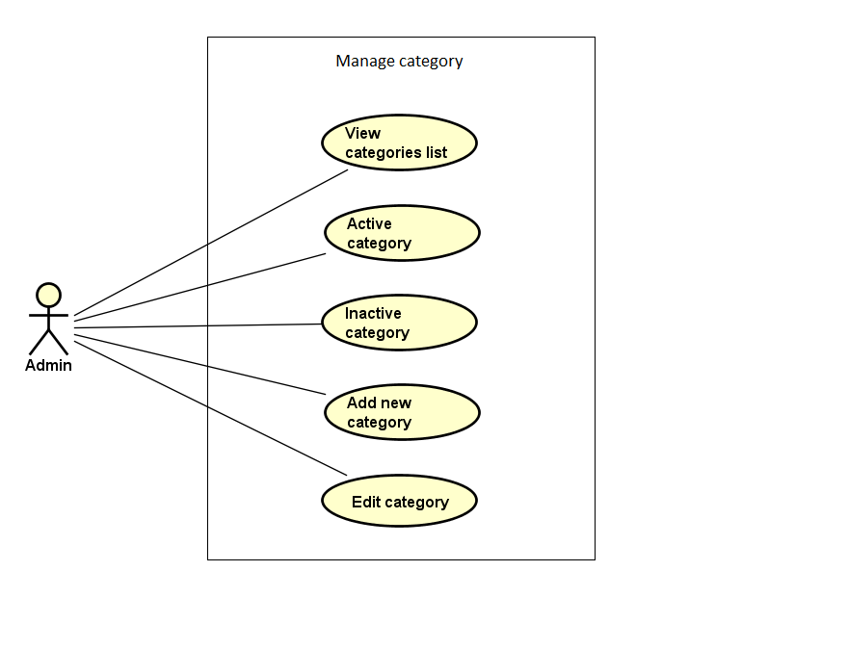

Figure 3-15: Manage event categories use case

##### UC054- View category list

|  |  |  |  |  |  |
| --- | --- | --- | --- | --- | --- |
| **Use Case ID** | | UC054 | **Version** | 1.0 | |
| **Use Case Name** | | View category list | | | |
| **Created by:** | | DuyTN | **Date Created:** | 11/11/2016 | |
| **Primary Actor** | | Administrator(Admin) | **Secondary Actor** |  | |
| **Priority** | | Normal | | | |
| **Frequency of Use:** | | High | | | |
| **Description:** | | This function allows Administrator to view Category list of the event | | | |
| **Preconditions:** | | 1. WS website is available 2. Admin browsed WS website 3. Admin logged in as Administrator | | | |
| **Trigger:** | | Admin clicks on Category | | | |
| **Post conditions:** | | Category List is displayed | | | |
| **Normal Flow** | | | | | |
| **Step** | **Actor** | **Action** | | | |
| 1 | Admin | Click on Category at left side | | | |
| 2 | WS | Display list of categories | | | |
| **Alternative Flows:** | | | | | |
| **AT1** | At step 1 in the main flows, if do not have any category | | | | |
| **Step** | **Actor** | **Action** | | | |
| 2.1 | WS | Display “Do not have any category” message | | | |
|  | | | | | |
| **Exceptions: N/A** | | | | |
| **Business Rules:** | | B1 | | |
| **Other Information:** | | N/A | | |

Table 2- 67: View category list Use case

##### UC055- Search category

|  |  |  |  |  |
| --- | --- | --- | --- | --- |
| **Use Case ID** | | UC055 | **Version** | 1.0 |
| **Use Case Name** | | Search category | | |
| **Created by:** | | DuyTN | **Date Created:** | 11/11/2016 |
| **Primary Actor** | | Administrator(Admin) | **Secondary Actor** |  |
| **Priority** | | Normal | | |
| **Frequency of Use:** | | High | | |
| **Description:** | | This function allows Administrator to search a category | | |
| **Preconditions:** | | Admin is viewing Category List | | |
| **Trigger:** | | Admin types name of category at Search textbox | | |
| **Post conditions:** | | Display list of searched category | | |
| **Normal Flow** | | | | |
| **Step** | **Actor** | **Action** | | |
| 1 | Admin | Type name of category which want to search | | |
| 2 | WS | Display list of categories which have the name is typed | | |
| **Alternative Flows:** | | | | |
| **AT1** | At step 1 in the main flows, if the typed name is not exist | | | |
| **Step** | **Actor** | **Action** | | |
| 2.1 | WS | Display “No matching records found” message | | |
| **Exceptions: N/A** | | | | |
| **Business Rules:** | | N/A | | |
| **Other Information:** | | N/A | | |

Table 2- 68: Search category Use case

##### UC056- Activate category

|  |  |  |  |  |
| --- | --- | --- | --- | --- |
| **Use Case ID** | | UC056 | **Version** | 1.0 |
| **Use Case Name** | | Activate category | | |
| **Created by:** | | DuyTN | **Date Created:** | 11/11/2016 |
| **Primary Actor** | | Administrator(Admin) | **Secondary Actor** |  |
| **Priority** | | High | | |
| **Frequency of Use:** | | High | | |
| **Description:** | | This function allows Administrator to activate a category | | |
| **Preconditions:** | | * Admin is viewing Category List * Status of this category is deactivate | | |
| **Trigger:** | | Admin clicks on Deactivate button | | |
| **Post conditions:** | | Category is activated | | |
| **Normal Flow** | | | | |
| **Step** | **Actor** | **Action** | | |
| 1 | Admin | Click on Deactivate button at Status column of the category which want to activate | | |
| 2 | WS | * Change displayed status from Deactivate to Activate * Change status of this category to Activate on database | | |
| **Alternative Flows: N/A** | | | | |
| **Exceptions: N/A** | | | | |
| **Priority** | | High | | |
| **Frequency of Use:** | | High | | |
| **Business Rules:** | | N/A | | |
| **Other Information:** | | N/A | | |

Table 2- 69: Activate category Use case

##### UC057- Deactivate category

|  |  |  |  |  |
| --- | --- | --- | --- | --- |
| **Use Case ID** | | UC057 | **Version** | 1.0 |
| **Use Case Name** | | Deactivate category | | |
| **Created by:** | | DuyTN | **Date Created:** | 11/11/2016 |
| **Primary Actor** | | Administrator(Admin) | **Secondary Actor** |  |
| **Priority** | | High | | |
| **Frequency of Use:** | | High | | |
| **Description:** | | This function allows Administrator to deactivate a category | | |
| **Preconditions:** | | * Admin is viewing Category List * Status of this category is activate | | |
| **Trigger:** | | Admin clicks on Activate button | | |
| **Post conditions:** | | Category is deactivated | | |
| **Normal Flow** | | | | |
| **Step** | **Actor** | **Action** | | |
| 1 | Admin | Click on Activate button at Status column of the category which want to deactivate | | |
| 2 | WS | * Change displayed status from Activate to Deactivate * Change status of this category to Deactivate on database | | |
| **Alternative Flows: N/A** | | | | |
| **Exceptions: N/A** | | | | |
| **Business Rules:** | | N/A | | |
| **Other Information:** | | N/A | | |

Table 2- 70: Deactivate category Use case

##### UC058- Add new category

|  |  |  |  |  |
| --- | --- | --- | --- | --- |
| **Use Case ID** | | UC058 | **Version** | 1.0 |
| **Use Case Name** | | Add new category | | |
| **Created by:** | | DuyTN | **Date Created:** | 11/11/2016 |
| **Primary Actor** | | Administrator(Admin) | **Secondary Actor** |  |
| **Priority** | | High | | |
| **Frequency of Use:** | | High | | |
| **Description:** | | This function allows Administrator to add new a category | | |
| **Preconditions:** | | Admin is viewing Category List | | |
| **Trigger:** | | Admin clicks on Add button | | |
| **Post conditions:** | | New category is added | | |
| **Normal Flow** | | | | |
| **Step** | **Actor** | **Action** | | |
| 1 | Admin | Click on Add Category button at right side of Category list table | | |
| 2 | WS | Display Add new category popup | | |
| 3 | Admin | * Type Category Name * Type Description * Choose picture from Admin’s computer * Click Add button | | |
| **Alternative Flows:** | | | | |

|  |  |  |
| --- | --- | --- |
| **AT1** | At step 3 in the main flows, if Admin click on Close button | |
| **Step** | **Actor** | **Action** |
| 3.1 | WS | Turn off Add new category popup |
|  | | |

|  |
| --- |
| **Exceptions:** |

|  |  |  |
| --- | --- | --- |
| **EC1** | At step 4 in main flow, if Admin does not type Category Name/ Description or does not choose picture | |
| **Step** | **Actor** | **Action** |
| 3.1 | WS | Display Add popup message with error message |
| 3.2 | WS | Mark error fields |

|  |  |
| --- | --- |
| **Business Rules:** | N/A |
| **Other Information:** | N/A |

Table 2- 71: Add new category Use case

##### UC059- Edit category

|  |  |  |  |  |
| --- | --- | --- | --- | --- |
| **Use Case ID** | | UC059 | **Version** | 1.0 |
| **Use Case Name** | | Edit category | | |
| **Created by:** | | DuyTN | **Date Created:** | 11/11/2016 |
| **Primary Actor** | | Administrator(Admin) | **Secondary Actor** |  |
| **Priority** | | High | | |
| **Frequency of Use:** | | High | | |
| **Description:** | | This function allows Administrator to edit a category | | |
| **Preconditions:** | | Admin is viewing Category List | | |
| **Trigger:** | | Admin clicks on Edit button | | |
| **Post conditions:** | | Category is edited | | |
| **Normal Flow** | | | | |
| **Step** | **Actor** | **Action** | | |
| 1 | Admin | Click on Edit button at Edit column | | |
| 2 | WS | Display Edit category popup | | |
| 3 | Admin | * Type Category Name * Type Description * Choose picture from Admin’s computer * Click Add button | | |
| **Alternative Flows:** | | | | |

|  |  |  |
| --- | --- | --- |
| **AT1** | At step 3 in the main flows, if Admin click on Close button | |
| **Step** | **Actor** | **Action** |
| 3.1 | WS | * Turn off Edit category popup * Keep old information of this category |
|  | | |

|  |  |
| --- | --- |
| **Exceptions: N/A** | |
| **Business Rules:** | N/A |
| **Other Information:** | N/A |

Table 2- 72: Edit category Use case

#### Manage sliders

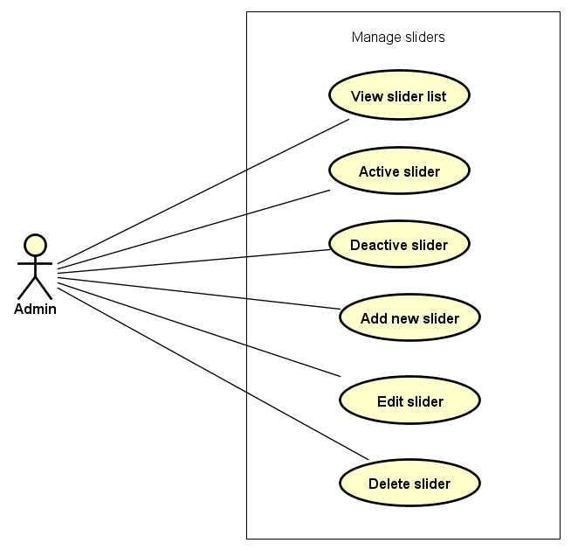

Figure 3-16: Manage slide use case

##### UC060- View slider list

|  |  |  |  |  |
| --- | --- | --- | --- | --- |
| **Use Case ID** | | UC060 | **Version** | 1.0 |
| **Use Case Name** | | View slider list | | |
| **Created by:** | | DuyTN | **Date Created:** | 11/11/2016 |
| **Primary Actor** | | Administrator(Admin) | **Secondary Actor** |  |
| **Priority** | | High | | |
| **Frequency of Use:** | | High | | |
| **Description:** | | This function allows Administrator to view Slider list of the event | | |
| **Preconditions:** | | 1. WS website is available 2. Admin browsed WS website 3. Admin logged in as Administrator | | |
| **Trigger:** | | Admin clicks on Slider | | |
| **Post conditions:** | | Slider List is displayed | | |
| **Normal Flow** | | | | |
| **Step** | **Actor** | **Action** | | |
| 1 | Admin | Click on Slider at left side | | |
| 2 | WS | Display list of sliders | | |
| **Alternative Flows:** | | | | |
| **AT1** | At step 1 in the main flows, if do not have any slider | | | |
| **Step** | **Actor** | **Action** | | |
| 2.1 | WS | Display “Do not have any slider” message | | |
|  | | | | |
| **Exceptions: N/A** | | | | |
| **Business Rules:** | | N/A | | |
| **Other Information:** | | N/A | | |

Table 2- 74: View slider list Use case

##### UC061- Activate slider

|  |  |  |  |  |
| --- | --- | --- | --- | --- |
| **Use Case ID** | | UC061 | **Version** | 1.0 |
| **Use Case Name** | | Activate slider | | |
| **Created by:** | | DuyTN | **Date Created:** | 11/11/2016 |
| **Primary Actor** | | Administrator(Admin) | **Secondary Actor** |  |
| **Priority** | | High | | |
| **Frequency of Use:** | | High | | |
| **Description:** | | This function allows Administrator to activate a slider | | |
| **Preconditions:** | | * Admin is viewing Slider List * Status of this slider is deactivate | | |
| **Trigger:** | | Admin clicks on Deactivate button | | |
| **Post conditions:** | | Slider is activated | | |
| **Normal Flow** | | | | |
| **Step** | **Actor** | **Action** | | |
| 1 | Admin | Click on Deactivate button at Status column of the slider which want to activate | | |
| 2 | WS | * Change displayed status from Deactivate to Activate * Change status of this slider to Activate on database | | |
| **Alternative Flows: N/A** | | | | |
| **Exceptions: N/A** | | | | |
| **Business Rules:** | | N/A | | |
| **Other Information:** | | N/A | | |

Table 2- 75: Active slider Use case

##### UC062- Deactivate slider

|  |  |  |  |  |
| --- | --- | --- | --- | --- |
| **Use Case ID** | | UC062 | **Version** | 1.0 |
| **Use Case Name** | | Deactivate slider | | |
| **Created by:** | | DuyTN | **Date Created:** | 11/11/2016 |
| **Primary Actor** | | Administrator(Admin) | **Secondary Actor** |  |
| **Priority** | | High | | |
| **Frequency of Use:** | | High | | |
| **Description:** | | This function allows Administrator to deactivate a slider | | |
| **Preconditions:** | | * Admin is viewing Slider List * Status of this slider is activate | | |
| **Trigger:** | | Admin clicks on Activate button | | |
| **Post conditions:** | | Slider is deactivated | | |
| **Normal Flow** | | | | |
| **Step** | **Actor** | **Action** | | |
| 1 | Admin | Click on Activate button at Status column of the slider which want to deactivate | | |
| 2 | WS | * Change displayed status from Activate to Deactivate * Change status of this slider to Deactivate on database | | |
| **Alternative Flows: N/A** | | | | |
| **Exceptions: N/A** | | | | |
| **Business Rules:** | | N/A | | |
| **Other Information:** | | N/A | | |

Table 2- 76: Deactivate slider Use case

##### UC063- Add new slider

|  |  |  |  |  |
| --- | --- | --- | --- | --- |
| **Use Case ID** | | UC063 | **Version** | 1.0 |
| **Use Case Name** | | Add new slider | | |
| **Created by:** | | DuyTN | **Date Created:** | 11/11/2016 |
| **Primary Actor** | | Administrator(Admin) | **Secondary Actor** |  |
| **Priority** | | High | | |
| **Frequency of Use:** | | High | | |
| **Description:** | | This function allows Administrator to add new a slider | | |
| **Preconditions:** | | Admin is viewing Slider List | | |
| **Trigger:** | | Admin clicks on Add button | | |
| **Post conditions:** | | New slider is added | | |
| **Normal Flow** | | | | |
| **Step** | **Actor** | **Action** | | |
| 1 | Admin | Click on Add Slider button at right side of Slider list table | | |
| 2 | WS | Display Add new slider popup | | |
| 3 | Admin | * Type Slider Title * Type Slider Description * Type Slider Url * Choose picture from Admin’s computer * Choose Button Color * Choose Slider Order * Choose status * Click Add button | | |
| **Alternative Flows:** | | | | |

|  |  |  |
| --- | --- | --- |
| **AT1** | At step 3 in the main flows, if Admin click on Close button | |
| **Step** | **Actor** | **Action** |
| 3.1 | WS | Turn off Add new slider popup |
|  | | |

|  |
| --- |
| **Exceptions:** |

|  |  |  |
| --- | --- | --- |
| **EC1** | * At step 3 in main flow, if Admin does not type Slider Title/ Slider Description/ Slider Url or does not choose picture/ Button Color/ Slider Order/ status | |
| **Step** | **Actor** | **Action** |
| 3.1 | WS | Display Add popup message with error message |
| 3.2 | WS | Mark error fields |

|  |  |
| --- | --- |
| **Business Rules:** | N/A |
| **Other Information:** | N/A |

Table 2- 77: Add new slider Use case

##### UC064- Edit slider

|  |  |  |  |  |
| --- | --- | --- | --- | --- |
| **Use Case ID** | | UC064 | **Version** | 1.0 |
| **Use Case Name** | | Edit slider | | |
| **Created by:** | | DuyTN | **Date Created:** | 11/11/2016 |
| **Primary Actor** | | Administrator(Admin) | **Secondary Actor** |  |
| **Priority** | | High | | |
| **Frequency of Use:** | | High | | |
| **Description:** | | This function allows Administrator to edit a slider | | |
| **Preconditions:** | | Admin is viewing Slider List | | |
| **Trigger:** | | Admin clicks on Edit button | | |
| **Post conditions:** | | Slider edited | | |
| **Normal Flow** | | | | |
| **Step** | **Actor** | **Action** | | |
| 1 | Admin | Click on Edit button at Action column | | |
| 2 | WS | Display Edit slider popup | | |
| 3 | Admin | Type all needed information | | |
| **Alternative Flows:** | | | | |

|  |  |  |
| --- | --- | --- |
| **AT1** | At step 3 in the main flows, if Admin click on Close button | |
| **Step** | **Actor** | **Action** |
| 3.1 | WS | * Turn off Edit slider popup * Keep old information of this slider |
|  | | |

|  |  |
| --- | --- |
| **Exceptions: N/A** | |
| **Priority** | High |
| **Frequency of Use:** | High |
| **Business Rules:** | B1 |
| **Other Information:** | N/A |

Table 2- 79: Edit slider Use case

##### UC065- Delete slider

|  |  |  |  |  |
| --- | --- | --- | --- | --- |
| **Use Case ID** | | UC065 | **Version** | 1.0 |
| **Use Case Name** | | Delete slider | | |
| **Created by:** | | DuyTN | **Date Created:** | 11/11/2016 |
| **Primary Actor** | | Administrator(Admin) | **Secondary Actor** |  |
| **Priority** | | High | | |
| **Frequency of Use:** | | High | | |
| **Description:** | | This function allows Administrator to delete a slider | | |
| **Preconditions:** | | Admin is viewing Slider List | | |
| **Trigger:** | | Admin clicks on Delete button | | |
| **Post conditions:** | | Slider deleted | | |
| **Normal Flow** | | | | |
| **Step** | **Actor** | **Action** | | |
| 1 | Admin | Click on Delete button at Action column | | |
| 2 | WS | Display Deleted confirm popup | | |
| 3 | Admin | Click on Delete button | | |
| **Alternative Flows:** | | | | |

|  |  |  |
| --- | --- | --- |
| **AT1** | At step 3 in the main flows, if Admin click on Close button | |
| **Step** | **Actor** | **Action** |
| 3.1 | WS | * Turn off Delete slider popup * Keep all information of this slider |
|  | | |

|  |  |
| --- | --- |
| **Exceptions: N/A** | |
| **Priority** | High |
| **Frequency of Use:** | High |
| **Business Rules:** | B1 |
| **Other Information:** | N/A |

Table 2- 80: Delete slider Use case

#### Manage message

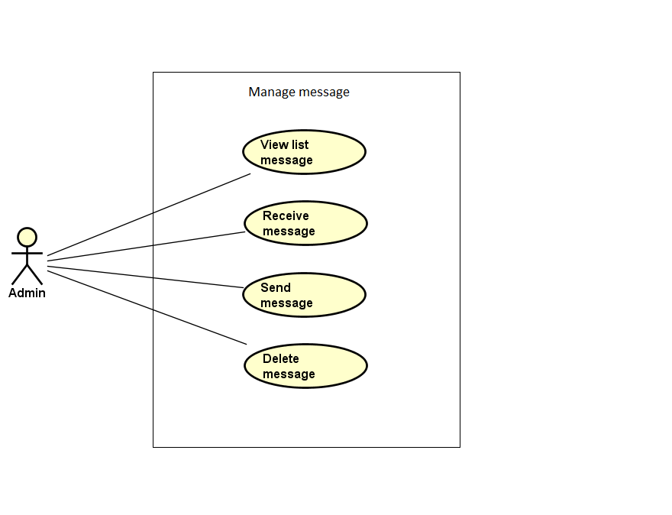

Figure 3-17: Manage message use case

##### UC066- View message list

|  |  |  |  |  |
| --- | --- | --- | --- | --- |
| **Use Case ID** | | UC066 | **Version** | 1.0 |
| **Use Case Name** | | View message list | | |
| **Created by:** | | DuyTN | **Date Created:** | 11/11/2016 |
| **Primary Actor** | | Administrator(Admin) | **Secondary Actor** |  |
| **Priority** | | High | | |
| **Frequency of Use:** | | High | | |
| **Description:** | | This function allows Administrator to view Message list of the event | | |
| **Preconditions:** | | 1. WS website is available 2. Admin browsed WS website 3. Admin logged in as Administrator | | |
| **Trigger:** | | Admin clicks on Message | | |
| **Post conditions:** | | Message List is displayed | | |
| **Normal Flow** | | | | |
| **Step** | **Actor** | **Action** | | |
| 1 | Admin | Click on Message at left side | | |
| 2 | WS | Display list of messages | | |
| **Alternative Flows: N/A** | | | | |
| **Exceptions: N/A** | | | | |
| **Business Rules:** | | N/A | | |
| **Other Information:** | | N/A | | |

Table 2- 81: View message list Use case

##### UC067- Delete message

|  |  |  |  |  |
| --- | --- | --- | --- | --- |
| **Use Case ID** | | UC067 | **Version** | 1.0 |
| **Use Case Name** | | Search message | | |
| **Created by:** | | DuyTN | **Date Created:** | 11/11/2016 |
| **Primary Actor** | | Administrator(Admin) | **Secondary Actor** |  |
| **Priority** | | High | | |
| **Frequency of Use:** | | High | | |
| **Description:** | | This function allows Administrator to delete a message | | |
| **Preconditions:** | | Admin is viewing Message List | | |
| **Trigger:** | | Admin clicks on Delete button | | |
| **Post conditions:** | | Delete message | | |
| **Normal Flow** | | | | |
| **Step** | **Actor** | **Action** | | |
| 1 | Admin | * Click on Delete button | | |
| 2 | WS | Delete message | | |
| **Alternative Flows: N/A** | | | | |
| **Exceptions:** | | | | |
| **AT1** | At step 1 in the main flows, if the typed name is not exist | | | |
| **Step** | **Actor** | **Action** | | |
| 2.1 | WS | Display “No matching records found” message | | |

Table 2- 82: Delete message Use case

##### UC068- Send message

|  |  |  |  |  |
| --- | --- | --- | --- | --- |
| **Use Case ID** | | UC068 | **Version** | 1.0 |
| **Use Case Name** | | Send message | | |
| **Created by:** | | DuyTN | **Date Created:** | 11/11/2016 |
| **Primary Actor** | | Administrator(Admin) | **Secondary Actor** |  |
| **Priority** | | High | | |
| **Frequency of Use:** | | High | | |
| **Description:** | | This function allows Administrator to send a message | | |
| **Preconditions:** | | Admin is viewing Message List | | |
| **Trigger:** | | Admin clicks on Send button | | |
| **Post conditions:** | | Message is send | | |
| **Normal Flow** | | | | |
| **Step** | **Actor** | **Action** | | |
| 1 | Admin | Click on New message button | | |
| 2 | WS | Display Send Message popup | | |
| 3 | Admin | * Type all needed information at popup * Click on Send button | | |
| 4 | WS | Send message to To email address | | |
| **Alternative Flows:** | | | | |
| **AT1** | At step 3 in the main flows, if Admin click on Close button | | | |
| **Step** | **Actor** | **Action** | | |
| 3.1 | WS | * Close Send Message popup | | |
|  | | | | |
| **Exceptions: N/A** | | | | |
| **Priority** | | High | | |

Table 2- 83: Send message Use case

##### UC069- View message

|  |  |  |  |  |
| --- | --- | --- | --- | --- |
| **Use Case ID** | | UC069 | **Version** | 1.0 |
| **Use Case Name** | | View message | | |
| **Created by:** | | DuyTN | **Date Created:** | 11/11/2016 |
| **Primary Actor** | | Administrator(Admin) | **Secondary Actor** |  |
| **Priority** | | High | | |
| **Frequency of Use:** | | High | | |
| **Description:** | | This function allows Administrator to view a message | | |
| **Preconditions:** | | Admin is viewing Message List | | |
| **Trigger:** | | Admin clicks on a message | | |
| **Post conditions:** | | Message is viewed | | |
| **Normal Flow** | | | | |
| **Step** | **Actor** | **Action** | | |
| 1 | Admin | Click on a message | | |
| 2 | WS | Display View Message popup | | |
| **Alternative Flows: N/A** | | | | |
| **Exceptions: N/A** | | | | |

Table 2- 84: View message Use case

#### Manage report

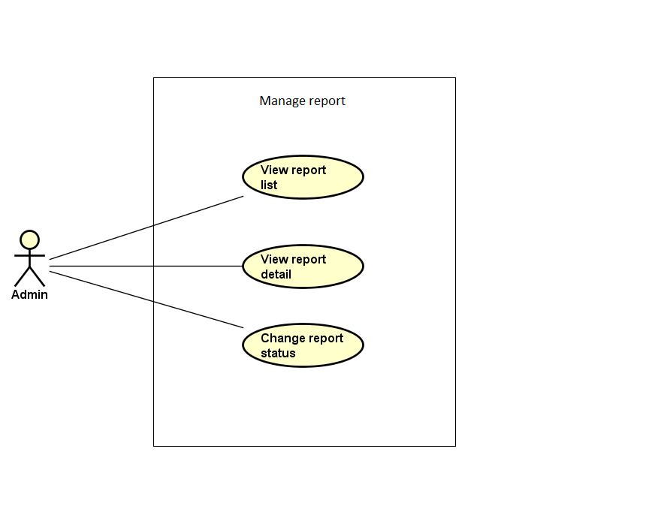

Figure 3-18: Manage report use case

##### UC071- View report list

|  |  |  |  |  |
| --- | --- | --- | --- | --- |
| **Use Case ID** | | UC071 | **Version** | 1.0 |
| **Use Case Name** | | View report list | | |
| **Created by:** | | DuyTN | **Date Created:** | 11/11/2016 |
| **Primary Actor** | | Administrator(Admin) | **Secondary Actor** |  |
| **Priority** | | High | | |
| **Frequency of Use:** | | High | | |
| **Description:** | | This function allows Administrator to view Report list | | |
| **Preconditions:** | | 1. WS website is available 2. Admin browsed WS website 3. Admin logged in as Administrator | | |
| **Trigger:** | | Admin clicks on User/ Event | | |
| **Post conditions:** | | Report List is displayed | | |
| **Normal Flow** | | | | |
| **Step** | **Actor** | **Action** | | |
| 1 | Admin | * Click on Report at left side * Click on User/ Event | | |
| 2 | WS | Display list of reports | | |
| **Alternative Flows: N/A** | | | | |
| **Exceptions: N/A** | | | | |
| **Business Rules:** | | N/A | | |
| **Other Information:** | | N/A | | |

Table 2- 86: View report list Use case

##### UC072- View report detail

|  |  |  |  |  |
| --- | --- | --- | --- | --- |
| **Use Case ID** | | UC072 | **Version** | 1.0 |
| **Use Case Name** | | View report detail | | |
| **Created by:** | | DuyTN | **Date Created:** | 11/11/2016 |
| **Primary Actor** | | Administrator(Admin) | **Secondary Actor** |  |
| **Priority** | | High | | |
| **Frequency of Use:** | | High | | |
| **Description:** | | This function allows Administrator to view information of a report | | |
| **Preconditions:** | | Admin is viewing Report List | | |
| **Trigger:** | | Admin clicks on button View at Action column | | |
| **Post conditions:** | | Detail of this report is displayed | | |
| **Normal Flow** | | | | |
| **Step** | **Actor** | **Action** | | |
| 1 | Admin | Admin clicks on button View at Action column of the user/ event which want to view report’s detail information | | |
| 2 | WS | Display View Report Content popup | | |
| **Alternative Flows: N/A** | | | | |
| **Exceptions: N/A** | | | | |
| **Business Rules:** | | N/A | | |
| **Other Information:** | | N/A | | |

Table 2- 87: View report detail Use case

##### UC073- Change report's status

|  |  |  |  |  |
| --- | --- | --- | --- | --- |
| **Use Case ID** | | UC073 | **Version** | 1.0 |
| **Use Case Name** | | Change report's status | | |
| **Created by:** | | DuyTN | **Date Created:** | 11/11/2016 |
| **Primary Actor** | | Administrator(Admin) | **Secondary Actor** |  |
| **Priority** | | High | | |
| **Frequency of Use:** | | High | | |
| **Description:** | | This function allows Administrator to change status of a report | | |
| **Preconditions:** | | Admin is viewing Report List | | |
| **Trigger:** | | Admin clicks on button at Status column | | |
| **Post conditions:** | | Status of this report is changed | | |
| **Normal Flow** | | | | |
| **Step** | **Actor** | **Action** | | |
| 1 | Admin | Admin clicks on button Waiting/ Cancel/ Confirmed at Status column of the user/ event which want to change report’s status | | |
| 2 | WS | * Display changed status as content of the button * Change status of report in database | | |
| **Alternative Flows: N/A** | | | | |
| **Exceptions: N/A** | | | | |
| **Business Rules:** | | N/A | | |
| **Other Information:** | | N/A | | |

Table 2- 89: Change report's status Use case

# **NON-FUNCTIONAL SPECIFICATION**

## **Reliability**

1. Mean time between failures: The mean time between each failure is expected to be about 360 hours of using.
2. The maximum bugs per function are 2 bugs/a function when user uses software within 2 months. The average number of bugs in the software during system testing is about to be around 1 bugs/KLOC.
3. The database must be backed up daily and can be recovered if necessary

## **Performance Requirements**

### **Availability**

The application must be available 95% of time. Users can access to it everywhere from their

Web browser with internet connection.

### **Maintainability**

* **Coding standards and naming conventions**
  + Output of the event must include coding standards and naming conventions documentations. Implementation code must be easy to maintain.
  + If some components are reused, the documentations of those components must also be included.
* **Design**
  + The design of the system must be loosely coupled that chances on some module will not affect others.
* **Logging**
  + All the errors should be logged, supporting for bug fixing and maintenance.
  + All strange or sensitive situations should also be logged.
* **Mean time to repair:** Immediately when Administrator finds out problem or website is attacked/ hacked by someone. Average 1 day.

### **Usability**

Usability Requirements support the following from the perspective of its primary users:

● **Efficiency of use:** user can complete each function in less than 10 actions

● **Intuitiveness:** User can understand approximately 90% help/ error messages

### **Security Requirements**

In order to avoid unwanted access by strangers, the security implemented in various ways:

1. **User authorize**: Each function must be distributed system access and manipulate the individual parts. To edit information, user must declare their username and password before the operation. Functions will be show after users login dependencies user’s role and permission of each user.
2. **Manage Data Layer**: Only Administrator can modify database system.

### **Hardware/Software Requirements**

● **Hardware requirement:**

**- Server:** IIS Express

**- Client:** PC/Laptop (window 7, window 8, 8.1)

● **Software requirements:** Web browser (Chrome 53.0, Firefox 30.0) with internet connection